University of Arizona
Internal Medicine

Intern Survival Guide
2023-2024

Preface
This UAIM Manual was created with the purpose of improving the efficiency of residents and to help interns familiarize and maneuver around the complexities of the health-care delivery system. It will require the input and feedback of all house staff as we aim to improve the contents of this mini-manual for it to better serve its purpose. We hope this guides you throughout your medical journey. This is only a guide and clinical judgment supersedes all.

Best of luck,
Justin Lee (2015), Alana Dembitsky (2015), Laith Ghazala (2015), Jennifer Segar (2015)
Ryan Wong (2018), Anthony Witten (2018), Joao Paulo Ferreira (2018)
Richard Young (2019)
Morgan Bailey (2020)
Martin Chacon (2021), Sumana Veeravelli (2021)
Samantha Russell (2022)
Elaine Cristan - Pulmonary Critical Care (2018)
Bhupinder Natt - Pulmonary Critical Care (2018)

If you have any feedback, please email moynahak@arizona.edu.

Feedback is greatly appreciated, and may include:
- Important and handy information that the handbook should contain
- Correction of errors in the information provided

Acknowledgements:
Special thanks to Drs. Justin Lee and Anthony Witten for passing down the Intern Survival Guide that served as the foundation of this newest edition.

Also a huge gratitude to Dr. Bhupinder Natt and Dr. Elaine Cristan for providing extensive input into this revised edition.

Letter from your ICU Faculty:

Medical ICU is an exciting and educational rotation for most residents, whether or not becoming an Intensivist is their career goal. There is immense learning potential and a lot that can be easily applied outside of the ICU.

The expectations for residents during the ICU are to learn and contribute to inpatient care, assist and perform common bedside procedures, be involved in family meetings and conversations, and attend didactic teaching sessions. Other duties and expectations may present themselves. Please refer to the residency rotation expectation documents.

ICU care is highly dependent on team approach. A typical team consists of attending physicians, fellows, residents, bedside nurses, pharmacists, respiratory therapists, physical therapists, social workers, nutritionist, and many other ancillary specialties. Everyone has a common goal of providing excellent patient care and there is no role for conflict or competition within the team. Respect others and their opinions.

This handbook is here to guide you to some important aspects of the rotation but is not an exhaustive source. We hope you have fun, learn and be an active contributing member of our team.

Sincerely,
Dr. Elaine Cristan, MD and Dr. Bhupinder Natt, MD

Contact Information
Chief Information:
- Brendan Andres: Veterans Affair chief – andresba@email.arizona.edu
- Mario Jaramillo: TMC/ Electives chief - mvjaramillo@email.arizona.edu
- Vinita Kusupati: Scheduling chief - vkusupati@email.arizona.edu
- Kevin Moynahan: BUMCT chief - moynahak@email.arizona.edu
- Chelsea Takamatsu: BUMCS/Clinic chief - ctakamatsu@email.arizona.edu

Scheduling Requests: vkusupati@email.arizona.edu
Elective Requests: vkusupati@email.arizona.edu or mvjaramillo@email.arizona.edu
[Please note: Schedule and Elective changes are not guaranteed and are difficult to accommodate with less than 60 days notice, please see scheduling change policy in the IM housestaff handbook for further details.]
Clinic Concerns: mvjaramillo@email.arizona.edu or ctakamatsu@email.arizona.edu

Amion: www.amion.com - Password uaim

New Innovations: www.new-innov.com - institution: ua
  - Log duty hours daily
  - Log Procedures as soon as completed
  - Complete Evaluations truthfully and soon after rotation
  - Log Scholarly Activities and Projects, QI projects
  - Location for Ground Rules, Conference Attendance Tracking

IM Office Contacts:
- Mary Gosciminski: IM Program Manager – marygski@arizona.edu
- Monica Jimenez: New-Innovations, Away Electives, notary public - mjimenez413@arizona.edu
- Julie Forte: Financial, Reimbursement, Travel Authorization - jforte3@arizona.edu
- Jazmine Aguilar: aguilarja@arizona.edu
- Hannah Cowling: hcowling@arizona.edu

Table of Contents
Contact Information 3
IM Office Contacts: 3
Banner UMC - Tucson 12
Paging: 12
Getting consult pager/extension numbers: 12
Codes 12
▪ BUMCT Sign-Out 12
BUMC Transfer Requirements 13
Transfer – Skilled Nursing Facility Placement (SNF) 13
Transfer – Acute Inpatient Rehab 14
Transfer- Long Term Acute Care (LTAC) 14
Transfer – Hospice 14
Transfer – Inpatient Psychiatry Placement 15
UMC Prescriptions 15
Home BIPAP/CPAP 16
Home - Durable Medical Equipment (DME) 16
Home Enteral feeding 17
Home Health: (home bound) 18
Home Infusion 18
Home nebulizer 19
Home Oxygen 19
Home TPN 20
Home Trach Care 20
Negative Pressure wound Therapy 21
UMC FAQ 21
What to do if I have computer/Cerner related problems? 22
Banner UMC - South 24
Locations: 24
General Admissions Workflow: 24
Signing-Inpatients (Handoff 25
Communication 26
Rapid Response Team 26
To Transfer patient to other BUMC system 26
Downgrade from ICU 26
Case Management Rounds 27
Other Key things to know about BUMCS 27
Translation 27
SAVAHCS 32
VA Paging: 32
Codes 32
Difficult to Find Orders 32
Medications Requiring Notes 32
Diagnoses Requiring Order Sets 32
VA Discharge Preparations 33
VA FAQ 35
TMC 38
TMC Codes 38
TMC FAQ 38
Approach to General Medicine Problems 40
Fever 40
Insomnia 42
Tachycardia 43
Bradycardia 46
Nausea 49
Pain 49
Bowel Regimen 50
Hypertension 50
Non-Emergent Blood Pressure Elevations in the Hospital: 51
Hypotension 51
Hypoglycemia 52
Hyperglycemia 52
Hyperosmolar Hypoglycemic State & Diabetic Ketoacidosis 53
Altered Mental status 57
Seizures 57
Chest Pain 58
Shortness of Breath/Respiratory Failure 59
ASTHMA/COPD Exacerbation 61
Comfort Care Medications 61
Electrolytes 62
Potassium 62
Hypokalemia 62
Hyperkalemia 63
Magnesium: 63
Calcium 64
Hypocalcemia 64
Hypercalcemia 64
Sodium: 65
Hyponatremia 65
Hypernatremia 68
Phosphorous 69
Hypophosphatemia: 69
Hyperphosphatemia: 69
INTRAVENOUS FLUIDS 70
Infectious Disease 71
Antibiotics: 72
Pneumonia 77
Sepsis 80
Hemodynamic Parameters 82
VASOACTIVE AGENTS 83
CARDIOLOGY 85
Cardiogenic Shock 85
Cardiac Drips 87
BASIC EKG INTERPRETATION 90
HEMATOLOGY 92
DVT 93
PE 93
Disseminated Intravascular Coagulation 96
Heparin Induced Thrombocytopenia 97
BLOOD COMPONENT THERAPY 98
Transfusion Reactions 98
Intensive Care Unit 99
ORGANIZATION OF NOTES 99
ICU PROPHYLAXIS 102
Supplemental Oxygen 103
Respiratory Failure 104
Non-invasive positive pressure ventilation 105
Invasive Mechanical Ventilation 106
Acute Respiratory Distress Syndrome (ARDS) 109
Trouble shooting high peak pressures 112
Acid/Base 112
Procedures 115
Central Lines 115
Paracentesis 115
Lumbar Puncture 116
Thoracentesis 117
Pleural Effusions 117
Definitions for chest tube management: 118
SEDATION 120
Paralytics 121
ABCDE Bundle 121
ICU References 123
How to call a consult 110
Antibiotic Coverage 112
ACLS Algorithms 113

Banner UMC - Tucson

Paging:
- How to page: dial the pager number (e.g. 520-446-XXXX), wait for the tone, then dial your call back number.
- How to dial 4-digit extension?
At BUMCT Dial 520-694-(xxxx); At BUMCS Dial 520-874- (xxxx)

Getting consult pager/extension numbers:
- Dial 0 to call the operator and ask for the number
- Search “http://bumgt.qgenda.com/” from a Banner/UMC computer or when logged in through the portal
- Keep in mind, some services are split. For example, nephrology has a general and ICU team, GI has general, interventional or hepatology. Know which team you are trying to reach.

Codes
BUMCT
Resident work room - 3857 | 9874
Resident work room - 3503 | 5832
Hospitalist room - 3640 | 0463
Resident work room - 4801 | 1478
ED Nutrition/bathroom | 6093
1NW codes | 9876
D2N Nutrition | 1492
D3N and bathroom | 0214
D3W | 5184
4NE Supply room | 365
4W Supply room | 2249
6NE Nutrition | 6523
6 Floor US | 6425
IM Resident Lounge - 6407 | 2589#
8EW | 8523
9NS | 9412
9NE | 9514
Banner Pantano Clinic | 2474

- BUMCT Sign-Out:
Occurs at 6:00 AM and 6:00 PM daily in the 3857 resident room for wards, the 7NS work room for MICU and the 6EW work room for CCU.

At the end of any ward shift, the intern will sign-out his/her patients to the housestaff on-call. The SAIF-IR handoff system will be utilized by off-going residents and oncoming residents during resident sign outs. The off-going resident sign out will include a Summary statement, Active issues, If-then contingency planning, and Follow-up activities. The Oncoming resident sign off must include Interactive questioning and Read-backs. Sign-out will also include team contact information, demographic information, code status, allergies, significant medical co-morbidities, and most relevant medications. Given the intricacies of transferring care to a cross-cover team, thoroughness and consistency is a requirement.

BUMC Transfer Requirements

Transfer – Skilled Nursing Facility Placement (SNF)
Place Case Management Consult for SNF placement
- Services must be skilled and need 24h care
  - Physical rehab (PT/OT), IV Abx, wound care
  - Any elderly patient that is not able to stand up without assistance should have a PT eval
- Some SNFs defer due to high cost of antibiotics /chemo/radiation drugs
- SNFs require a TB clearance: CXR or PPD
  - Don’t forget to check the TB clearance box at departure
- Therapy sessions: 30 to 60 mins.
- Patients must require 24-hour nursing care
- Physicians only visit 1-2 times per week
- Respiratory care and oxygen:
  - Many SNFs w/o RT coverage
  - Many SNFs require liter flow (i.e., <4-5L)
- Pt must be “sitter/restraint free” for at least 24 hours prior to discharge
- May reject pts with current/previous substance use
- Traditional Medicare: Pt must be an inpatient for at least 3 midnights for a SNF stay to be covered
- Orders include: PT/OT evaluation, CXR to rule out TB, and prescriptions for controlled substances (3-day supply), and bariatric equipment. Eg: (1) Bariatric Bed, (2) Bariatric Commode, (3) Bariatric walker, (4) Bariatric wheelchair.

Transfer – Acute Inpatient Rehab
- Require minimum of two modalities (Ie. PT or OT or ST) and tolerate at least 3 hours of rehabilitation daily
- Patients must be medically complex requiring daily physician visits
- Active chemotherapy/radiation and patients with restraints are usually excluded
- Payer considerations: Most of the managed care plans (including Medicare and AHCCS plans) require that patients need all 3 therapy modalities (OT, PT and ST) to qualify for coverage
- Traditional Medicare does not have a prior authorization requirement

Transfer- Long Term Acute Care (LTAC)
- Patients must be medically complex with stable, long term acute care needs.
- LTACHS typically are appropriate for patients requiring long term vent weans, very complex wound care, and IV antibiotic needs.
- LTACHS also provide physical rehabilitation
- Payers consideration: Patients insured by managed care plans must have LTACHS services preauthorized. Medicare does not have a prior authorization requirement.

Transfer – Hospice
Hospice Criteria
- Life expectancy of 6-months or less who are seeking comfort measures and do not wish to pursue curative treatment
- Patients must have a “hospice diagnosis” and require symptom management
- Hospice options:
  - Inpatient: active and ongoing symptom stabilization or at the very end of life when symptoms cannot be managed in the home setting.
  - Home Hospice or Hospice at care facility. Home hospice will include nursing visits a couple times a week, but the majority of care will rely on household members.

Who to Consult when Deciding Hospice:
- If patient/family decides on hospice, consult Hospice Social Worker. No need to consult palliative care team. Order should state “evaluate and treat”.
- If family/patient is unclear and unsure of goals of care, you can consider palliative medicine consult.
- Banner does have an inpatient hospice facility – however, never promise a family inpatient services. Many patients do not meet inpatient needs. The hospice team will evaluate for appropriate hospice dispo.

Payor: hospice agency responsible for all care, including DME
- Some agencies discount rates or offer charity care for patients without resources.
- Some providers cover the cost of transportation for patients for in-city transportation.
- Payer considerations: No prior auth, except Medicaid/AHCCS plans do not cover

Transfer – Inpatient Psychiatry Placement
At psychiatry recommendations, place Social Services consult for Inpatient Psychiatry Placement. Transfer is dependent on ability to deem patient medically stable for transfer. At this time and when Level 1 Psychiatry bed available, can discharge the patient. Make sure you communicate discharge recommendations as psychiatry will discharge the patient from the Level 1 Facility when psychiatrically clear

Orders to consider: urine toxicology/drugs of abuse screen, EtOH level, salicylate level, acetaminophen level, thyroid, current CBC and BMP, EKG (QTc), and pregnancy screen if gender/age appropriate.

UMC Prescriptions
Some medications require prior authorization (i.e. ticagrelor, DOACs, enoxaparin, rifaximin, IV antibiotics, some PO antibiotics). Discuss with floor pharmacist if medication planned for discharge requires prior authorization (PA, frequently used as an acronym in case manager and pharmacist notes.)

If you need a PA, you might need to send prescription to pharmacy before day of discharge so that PA process can be completed prior to discharge.

Home BIPAP/CPAP
Place Case Manager Consult in orders for home DME – Bipap through the Depart Menu and Miscellaneous Prescription

BIPAP Covered for:
- Restrictive Thoracic Disorders (ie neuromuscular disease or severe thoracic cage abnormalities)
- Severe COPD
- Central Sleep Apnea or Complex Sleep Apnea
- Hypoventilation Syndrome

CPAP Covered for:
- Apnea- hypopnea index (AHI) or Respiratory Disturbance Index (RDI) greater than or equal to 15 events per hour with a minimum of 30 events; OR
- AHI or RDI greater than or equal and less than or equal to 14 events per hour with a minimum of 10 events and documentation of excessive sleepiness, impaired cognition, mood disorders, insomnia, or hypertension

- Starting new BiPAP or CPAP in the hospital requires Pulmonary Consultation
- Rx: “Bipap settings, IPAP: 12, EPAP 5, Oxygen at 2L per minute bleed into BIPAP”
- Rx: “CPAP Settings, EPAP 8cmH20, Oxygen at 2L per minute bleed in”

Home - Durable Medical Equipment (DME)
Please place case manager order for Home DME, DME through Depart & PT/OT consult is helpful

Medicare guidelines: Must meet requirement for each specific type of equipment

A. Document in a progress note for hospital beds:
I. The patient requires the head of the bed to be elevated more than 30 degrees most of the time due to CHF, COPD or problems with aspiration; OR
II. The patient requires positioning of the body in ways not feasible with an ordinary bed to alleviate pain.

Required Prescription:
- “Semi electric Hospital bed (half or full rails), for head of bed 30 degrees or greater, positioning that is not possible in a regular bed to reduce pain”
- “Heavy Duty Hospital bed (include pt. weight)”

B. Document in a progress note for wheelchairs:
- Mobility limitations that significantly impairs his/her ability to participate in ADL’s (i.e toileting, feeding, grooming, and bathing in the home), and mobility limitation cannot be sufficiently and safely resolved by use of appropriately fitted cane or walker.
- Use of a manual wheelchair will significantly improve the patient’s ability to participate in mobility related activities of daily living and the patient will use it on a regular basis in the home.

Required Prescription:
- Wheelchair (specify type- elevated leg rests, removable arms or reclining). Patient’s limitation cannot be sufficiently and safely resolved by the use of appropriately fitted cane or walker.

C. Document in a progress note for walkers:
- Patient has mobility limitations that significantly impairs his/her ability to participate in mobility- related activities of daily living (i.e. toileting, feeding, grooming, and bathing in customary location in the home), and mobility limitation cannot be sufficiently and safely resolved by use of appropriately fitted cane
- The functional mobility deficit can be sufficiently resolved with the use of a walker.

Required Prescription:
- “Platform walker (specify right or left)” or “Front Wheeled Walker “

Home Enteral feeding
Place Case Manager consult for home health – tube feeds
Patient must have PEG tube, GJ tube or J tube for home feeds.
- It is difficult to send a patient with DHT but it has occasionally been done
Prescriptions: NEED Tube Feed, supplies and tube care.
- “Home Health Tube feeds via G tube. Peptamen AF at 80 ml/hr. G tube care and supplies. “
- “Tube feeding Pump:
  - 1 Box Tube feeding bags with tubing, 15 or per par level (Refill x3)
  - 1 Box syringes for Tube feed flush (Refill x3)”

Home Health: (home bound)
Place Case manager consult in orders for home health, requires Physician Face to Face and require 3 different modalities

Services available in the home include but are not limited to: Skilled Nursing for Home health safety evaluation, wound care and monitoring, medication management and teaching, cardio pulmonary assessment, physical and occupational therapy.

Prescriptions required (examples):
- “I certify that this patient is under my care and I had face to face encounter that meets the physician face to face encounter requirements with this patient on “todays date”.
- “Home Health – PT/OT Evaluate and treat”
- “Home Health RN for medication management and teaching”
- “Home health RN for wound care, assessment and caregiver training dressing change to ( example leg). Moisten kerlix with normal saline, gently pack wound and cover with 4x4.”
- “RN for Home health safely evaluation”
- “Okay to resume previous Home health orders”
- “Home health RN for Cardiopulmonary Assessment Evaluation and treat”
- “Home Health RN for ostomy care, changes and teaching.”

Home Infusion
- Patient will need PICC or Port upon discharge.
- Place Case Management Consult for Home Health for IV antibiotics and to establish following physician
- Place Social Services Consult for Screening of Psychosocial Appropriateness of Home infusion

Prescriptions Require:
- Medication start/stop date
- Weekly Labs if indicated, fax number of following provider (depart menu)
- Must have Outpatient provider following
  - “Nafcillin 12 gms IV continuous over 24 hrs. Stop date 8/25/2019. Following MD name.”
  - “Weekly CBC, BMP. Fax results to (number), attention: MD name.”
  - “Home health RN for (specify line) care and supplies.”

Home nebulizer
Nebulizer covered for these drug/diagnosis combinations only:

Diagnosis | Drug
COPD | Albuterol, budesonide, cromolyn, formoterol, ipratropium, levalbuterol, or metaproterenol
CF | Dornase Alpha
CF, Bronchiectasis | Tobramycin
HIV, Pneumocystosis, Complication of organ transplants | Pentamidine
Persistent thick or tenacious pulmonary secretions | acetylcysteine

Required documentation:
- Written order that contains valid prescription
- Patient Demographics (face sheet)
- Items to be dispensed with diagnosis
- Treating physician name and signature

Required prescriptions:
i.e.: “Small volume nebulizer”
i.e.: “Ipratropium 0.5 mg/albuterol 2.5 mg nebs, 3ml nebulizer every 4 hrs.”

Home Oxygen
Place Nursing Communication for Home O2 Evaluation. Must satisfy Medicare guidelines:
- PaO2 at or below 55mmhg or
- SaO2 at or below 88% (awake, sleep, and at rest)

Place Case Manager consult in orders for Home DME – Home oxygen
If the test results qualify only when the patient is under exertion, need to document:
- on room air, at rest
- on room air during exertion
- on oxygen during exertion
- Five continuous minutes of RASaO2 while sleeping
If the test is done during sleep, the test must show at least 5 minutes (not continuous) below the qualifying rate. This must be completed within 48 hrs of discharge.

For Medicare coverage: Information must be in H&P or progress note.
Examples of correct prescriptions- adjust rate or delivery as necessary:
i.e.: “Home O2 2 L via NC continuous for 2 months.”
i.e.: “Home O2 2L via NC ambulating for 30 days.”
i.e.: “Home O2 2L via NC while sleeping for 2 months”

Home TPN
Place Case Management Consult for Home Health for TPN including following Physician. Needs a dedicated line for TPN.

Prescriptions: Home health for TPN, line care and supplies.
Case Management will contact the TPN Pharmacy team for formulary.
Prescription: “Home health for TPN, PICC line care and supplies.”

Home Trach Care
Place case manager consult for home health for trach care and supplies – including following physician.
Prescription: Home supplies for post op tracheostomy, supplies, and CVP assessment.
i.e.: “Home health RN visit for CVP assessment and post op instruction for tracheostomy.”

Sample of checklist:
[ ] 2 trach tubes, including size and type ( refills x6)
[ ] 5 trach ties sets, refills x6
[ ] 2 boxes of sterile gauze 4x4 to clean trach/suture sites, refillsx3
[ ] 30 trach care kits, with 3x refills
[ ] 1 home suction machine with 2 suction machine tubing replacements ( allowed 2 tubings per month) refills x3
[ ] 1 home humidification machine with 2 blue tubing replacements refill x3
[ ] 1 box trach sterile suction catheters, size ( 14 or 12 french) refill x3
[ ] 2 tracheostomy shields for humidification refill x3
[ ] foam wedge 30 degrees to elevate head of bed 30 degrees.
Written: Scripts for Private Purchase items/not covered by insurance:
[ ] 1 box wooden q tips for trach site cleaning: refills x3 ( metromed Tucson)
[ ] Sterile water bottles x6, with refills 3x ( Metromed tucson, or Retail Pharmacy)
[ ] Sterile 3cc saline bullets, 1 box, with 3x refills ( medline.com)
[ ] Box of exam gloves x2, with refills x3
MD signature and NPI required

Negative Pressure wound Therapy
Place Case manager consult in orders for negative pressure wound therapy including type of device. Complete company specific order form including wound description, wound measurements, necessary supplies, MD signature and NPI number.

Prescription: Home health for dressing changes if discharging home, not required for facility placement.
i.e.: Home health for negative pressure wound therapy dressing changes, changes 3 times a week, with black sponge and verify pressure at 125 mmHg.

UMC FAQ
How to request for medical records?
- Get the “medical record request form” from front desk in any unit and fill it in.
  - Can also be a nursing communication order if you communicate with the nursing staff.
- Call the hospital/clinic which you would like records from and speak to their medical records person to ask for their fax number. Tell them which patient you are requesting. For after office hours, ask their operator to speak to the on-call medical records person.
- Fax request

How to perform proper medication reconciliation?
- Call patient’s pharmacy/facility
- Pharmacy consultation

How to communicate in a different language?
- In person, phone, and video interpreters are available.
- In person Banner Spanish Interpreters can be reached during weekday business hours at (520) 694-4960.
- Phone translating services are available at (844) 203-2025, account #501028359, Pin #1000.
- Please make sure that when you use an interpreter you use this auto text “..Interpretation Documentation” in your note and fill out completely.
- If you are not going to use a certified interpreter & instead translate with the family - the patient must waive the use of the interpreter - documentation must be done. There is a form that needs to be signed for this.

How to get home Cerner access?
- Ask IT and have it set up

What to do if I have computer/Cerner related problems?
- Call Help Desk at 520-694-“HELP”
- Or STAT physician Banner IT at 520-694-7828

Banner UMC - South

Locations:
1st Floor: Cafeteria
2nd Floor
- Hospital Entrance
- Emergency
- ICU
- Cardiology – Cath lab/Stress Test
3rd Floor
- Physician lounge
- Staff Gym
- Team Rooms A and B
- Room 3030: Morning report/other meetings
- Administration
4th and 5th Floors
- In patient/Medicine Floors
- “Fishbowl” – 4th floor
- Case Management
- Sim Room – 5th floor
**Please see Map below for Hospital layout**
Room | Codes
Call Rooms (3rd Floor) | 4-5-2-3 Enter
IM Rounding Rooms | 4-5-2-3 Enter

**To access Sim Room (Fifth floor), please notify Chief Resident**

General Admissions Workflow:
1. Admissions cycle through all inpatient medicine teams. No longer an “on-Call” team.
i.e. Team A >> Team B >> Team C >> Team A >> Team B …
.
**Please be mindful internal medicine shares inpatient duties with our family medicine colleagues; the inpatient teams are designated at Team Orange and Team Red; the observation team is designated as Team Yellow**

2. Admission cycle does not change on nights. It continues throughout the day. (i.e. Team A gets a direct admit at 4:30 PM, Team B is the next team up after 5 PM). No reset of the cycle.

Some things to review during admissions and when getting ready for round
Home Medications verified by MD
EMR Orders reviewed
Can Abx be switched to Oral?
Need for IV Fluids
Diet Orders
UOP/Foley and Last BM
Tele, Oxygen, Tubes needed
Deconditioning – PT/OT needs
DVT prophylaxis
Code Status
Case Management needs
Discharge planning, Insurance issues and social barriers
Scripts to be filled before weekend
Family informed

Signing-Inpatients (Handoff):
Occurs at 6.00 AM and 6:00 PM daily in the physician lounge (3rd floor) for wards and in the physician workstation area in the ICU.

At the end of any ward shift, the intern will sign-out his/her patients to the housestaff on-call. The SAIF-IR handoff system will be utilized by off-going residents and oncoming residents during resident sign outs. The off-going resident sign out will include a Summary statement, Active issues, If-then contingency planning, and Follow-up activities. The Oncoming resident sign off must include Interactive questioning and Read-backs. Sign-out will also include team contact information, demographic information, code status, allergies, significant medical co-morbidities, and most relevant medications. Given the intricacies of transferring care to a cross-cover team, thoroughness and consistency is a requirement.

Communication
Please be aware, BUMCS uses an ASCOM system (which are phones); please dial extension 874 before the given 4 digit number i.e. 874-XXXX to call any service. Pagers aren’t used. (Team extension and contact information for phones are below). You are to pick up the phones in the morning after sign-out in hallway of the Team A and Team B rooms.

Rapid Response Team
There is not a designated rapid response team, primary services are responsible for their patients. If you are not a member of the primary team and no medicine team is near, please assist with rapid response or facilitate code until either primary team (for rapid) or ICU (for code) arrives bedside.

To Transfer patient to other BUMC system:
- Call Patient Placement (dial zero and ask for “patient placement”) who will then put you in contact with the med captain at BUMCT or other Banner facility.
- When speaking to the med captain, you will be asked reason for transfer, reason for hospitalization and pertinent information about patient’s medical history and hospitalization.
  - If accepted, you will have to place an order
  - Discharge to other acute care facility
- In comments place name of facility, accepting physician and time for transportation
- Please be mindful that when transferring a patient, the depart needs to be completed and a discharge summary is needed and should be completed before patient arrives into transferring facility.

Downgrade from ICU:
When in the ICU at south, If you are asked to downgrade the patient to a medical service, you will do so through patient placement (520-694-5868). They will give you a team that will be evaluating the patient for downgrade; and you will give the sign-out to that team. The downgrade order will come from the medicine team if they accept the patient.

Case Management Rounds:
You may be asked to present your patient for Case Management rounds
For rounds:
- You will be asked reason for hospitalization and Case Management or Social Work needs
- Please follow up with Case Management and/or Social Worker before discharge to see if anything is outstanding or for any other needs that may prevent discharge.

- To Send for an Interventional Radiological Procedure; you first need to call Betty Jo (446-0114) and fax order documents to 520-694-9613; after that you need to confirm the appointment. Once this is done, you will need to inform and confirm transportation with the case management department.
- Imaging may be busy so need to call the department and inform if urgent imaging is needed

Other Key things to know about BUMCS:
Specialty Services not available on weekends. Some services like Hematology-Oncology and ENT do not regularly rotate at south.
There is an administrative assistant (Rene Langenbach) at BUMCS that can assist with obtaining medical records; her extension is x 6855
We have an inpatient psychiatric service at BUMCS that is located on the second floor of the behavioral health pavilion and an inpatient geri-psychatric service that is located on the 5th floor. Please be familiar with how to access these locations as you will often get called for consults and may have to assist with rapid responses/codes in those locations.

Translation:
For Spanish translation service at BUMCS, you can call x2931 to request an in-person translator; for interpretation services (for various languages) via phone, please dial 877-218-9052.
Please note at BUMCS we have video remote interpretation service devices on the medical floor and in the emergency department.
** when requesting interpreter (in-person, phone, or video)- please have patient’s MRN readily available**

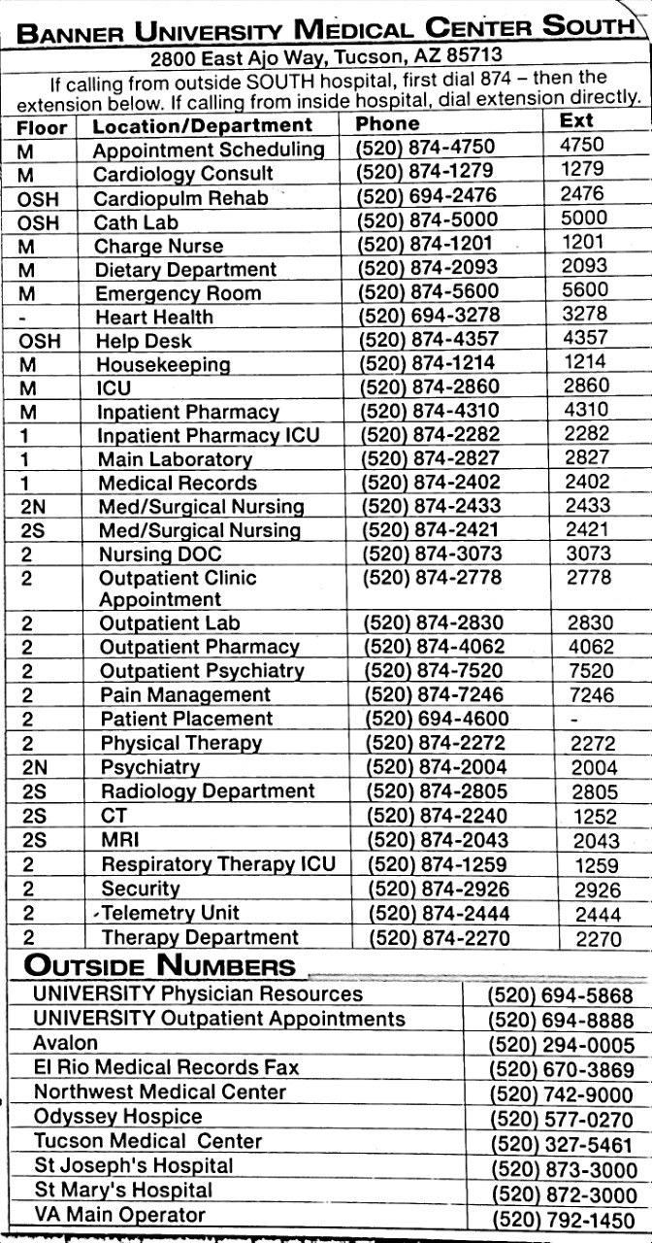

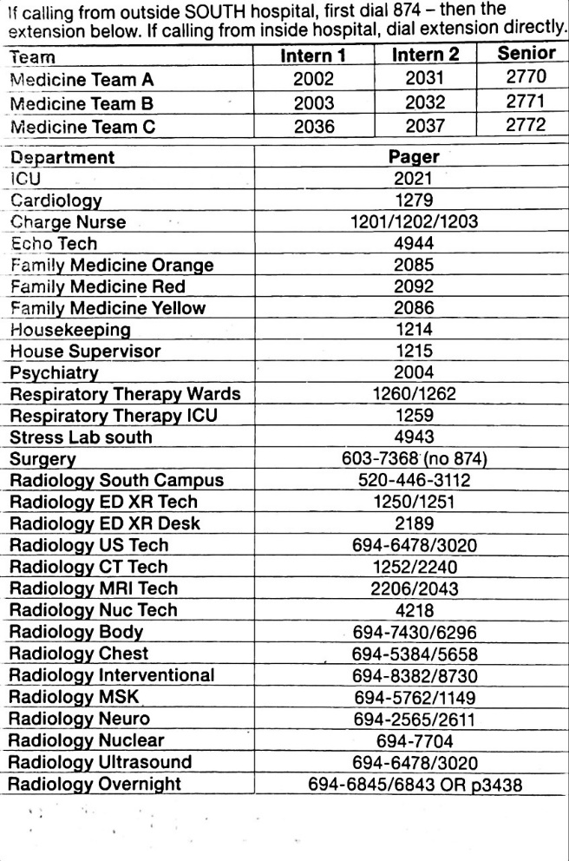

A few more numbers that might be helpful:
Arizona Kidney Disease & Hypertension Centers (AKDHC): (520)529-6500; (520)622-3569
Central Scheduling for outpatient appointments: (520) 694-8888

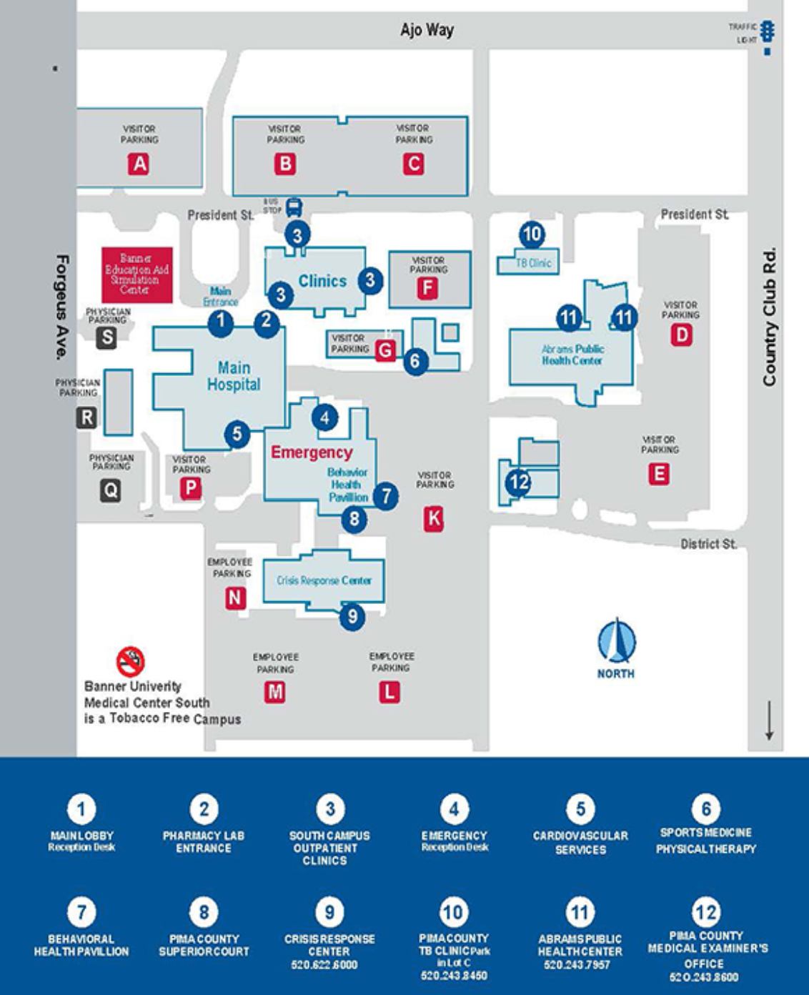

Southern Arizona VA Healthcare System

SAVAHCS

VA Paging:
- To get the consult pager numbers, either:
  - Open internet explorer, click the “on call rosters” button
  - Call operator
- To page VA pager, dial 1-5555, then choose user paging.
- To page UMC pager from the VA, dial out using 91, then 520-446-xxxx.
- To page VA pager from outside the VA, dial 520-629-4650
- To page UMC pager from outside UMC, dial 520-446-xxxx.

Codes
VA Wards Team A | 80
VA Wards Team B | 6729
VA Wards Team C | 6729
VA Wards Team D | 8363#
Physician Room (4th floor) | 2133#
TeleICU | 612-725-8000

Difficult to Find Orders
Blood Product Transfusion: Blood Bank & Nursing Transfusion Orders
Arterial Blood Gas: Respiratory Consult
CIWA: New Orders -> Mental Health (Left Column)
ECHO: New Procedures in Consults tab or bottom left or orders tab by EKG
Infusion Builder: Meds IV Medication Menu
Insulin (drip and sub q): All orders -> Insulin Orders (Center Column)
IV Abx, fluids, drips: Meds IV Antibiotic Menu

Medications Requiring Notes
Albumin: Med Albumin
Fluoroquinolones: Med Fluoroquinolone Outpatient
Olanzapine IM: Med Olanzapine IM
Oseltamivir: Oseltamivir

Diagnoses Requiring Order Sets (Bad, but Tracked)
- COPD
- Heart Failure
- Pneumonia
- Sepsis
- COVID-19
- Delirium

ICU Admission with Mechanical Ventilation
- Mechanical Ventilation Note: Includes Weaning Protocols, Sedation and SBT Protocol
- ICU sedation and Analgesia: Notes med sedation/analgesia/nmba
- Ventilator Withdrawal at End of Life (palliative orders also)

VA Discharge Preparations
- Pharmacy: med reconciliation for patients going home or non-VA intermediate care
  - Hard copy prescriptions are needed for any Class-2 Narcotics. Scripts are in the 4th floor medicine office. Place prescription in the patient’s chart on the floor or give to the social worker.
Nurse Case Manager:
- Assess and refer for home health needs
- Make Referrals to the Community Living Center (CLC)

Social Worker:
- Assess social needs, placement
- Advance Directive
- Transportation

For specific discharge instructions, please see the file in the “Medicine Res” Folder in the S: Drive.

Home BiPAP/  CPAP | - 1 day notice needed  - Pulmonary consult mandatory | Office contact:  Person: Dorothy Coffman.  Room: A104 (At the entrance of the CDU)  Extension: 4596
Home Oxygen | You do oxygen assessment (O2 sat walking, resting and nocturnal and write it down in “home oxygen” note) OR contact home oxygen office and they do the workup. | Home Oxygen Office:  Person: Heather Maller  Room: A148 (At the entrance of the CDU)  Extension: 6299
Community Living Center (CLC) placement | CLC include:  - Acute Rehab  - Complex medical conditions  - Wound Care/ Vac  - Geri-Psych unit and Geri clinic for dementia patients  - Stroke unit  - Palliative or active chemo/radiation  - Hospice  - IV antibiotic  - TPN  - Enteral feeding. | Requirements:  - Patient will qualify if requires at least 3-4 weeks of placement.  - Discharge summary needs to be ready  - Social work consult  - Social work fills the CLC consult  - Bowel movements within 48 hours  - CXR to rule out active TB  - If acute rehab is the main reason, can patient engage in 3 hours rehab  - If IV antibiotic, need a PICC. Consider ID Cx  - For chemo/rad, palliative Cx
Trach patient | - Transfer patient from SDU to ward to CLC based on # of suctions/shift.  - CLC require one suction per shift.  - Fresh < 6 months, old > 6 months | Option of placements depend on  - Date of the trach  - # of suctions/shift  - Patient physical status  - Patient can suction or not  - 2 options either CLC (w/ rehab) or Foothills
Home Antibiotic: | - SW & CM  - Needs a PICC
Home enteral feeding | - SW & CM  - Nurse train patient on feeding tube.  - Enteral tube kit

VA Hospice and Palliative Care
Hospice Requirements:
- Life expectancy < 1m inpatient; < 6m for outpatient
- DNR
- Consent for hospice (pt. requests comfort care only)
- Consult hospice if pt needs more information, otherwise SW

Comfort Care Medications
- Dilaudid 0.5mg SQ q1h PRN pain
- Oxycodone 5-10mg q3-4hrs PO PRN pain
- Versed 1-2mg SQ q4h PRN anxiety
- Lorazepam 0.5mg-1mg PO q4h PRN anxiety
- Haldol IV/IM- check dosing recommendations/with senior
- For respiratory rattling
  - Atropine 1mg SQ q4hr PRN
  - Glycopyrrolate 0.6mg nebs q4hrs PRN

Palliative: Symptom management with life threatening disease process, i.e. undergoing radiation treatment/continuation of chemotherapy: Consult Palliative

VA FAQ
Set Up Printer
- Open the Printer Server Icon on the Desktop
- Find the Team Room Printer and double click
- Set as Default Printer under “Printer and Scanners”

How to set up home computer access?
https://vpnportal.vansoc.va.gov/SelfService/
- Supervisor: Frances Trinidad
- Subsequently, log-ins are via: citrixaccess.va.gov
- You will need a PIV card reader from Frances Trinidad
- Call: 1-800-877-4328 if you have any problems

CPRS related issues
- You can create your personalized “lab result trend”. Try clicking on Lab worksheet

How to get consent?
- CPRS Action tab Imed consent, bring computer to pt’s bedside, after getting verbal consent, ask pt/surrogate to sign on the signature pad

TMC

TMC Codes
Codes for call rooms
Medicine Lounge | 1st door: 54321; 2nd door 49491
AIM Call Room Code | 0919

TMC FAQ
Managing the Treatment Team?
It is important to associate your team to each patient. This is the only way hospital staff will be able to contact you. Select the team name (i.e. Team A) from the dropdown menu under Treatment Team. For seamless communication, please fill out the Treatment Team as soon as you accept a patient onto your service.

How to place a consult at TMC?
Many subspecialists/subspecialist groups go to TMC.
- If a patient has an existing subspecialist provider, consult the patient’s existing provider
- If the patient does not have an existing provider, please ask your attending who they would like consulted. If no preference, call the ED for Specialist on Call.

Place a consult in the computer. Consultants have 24 hours to respond. For urgent (within 12 hours) or emergent (within 4 hours) consults, you will need to call the physician office. The operator can assist you with this number. Most office have an answering service and will send a page to the consult to call you back. For completeness, you should enter the patient’s provider and reason for consult in the consult order.
Avoid the “on call for the ER” consults unless your attending tells you to do this. Consult relationships extend past the admission, so please choose carefully and let your attendings guide you.

How to pick up a parked/channel call?
Specialists may use this method to contact residents. You’ll receive a 3-digit page starting with 7or hear an overhead page. To answer this call, from any TMC land line, push # + 7 + the 3 digit number. The channel stays open only 2 min. If the caller hangs up, you will hear a two-tone sound (like an ambulance siren) and will need to call the operator.

Approach to General Medicine Problems
IF IN DOUBT… SEE THE PATIENT!!!! And tell your Senior. The best residents are the ones who know when to call for help. The following is only a guide to help you, every patient is different and you must use your own clinical judgment.

IF YOU ORDER SOMETHING YOU HAVE TO FOLLOW IT UP OR SIGN IT OUT!!!

Fever:
**Fever is elaborated on in the Infectious Disease Section**
DDx: very broad, including infectious, inflammation, thrombosis, drug fever, endocrine abnormalities, neurologic injuries, post-surgical and more.
- Infection
  - Most common- UTI, PNA (CAP, HAP, VAP)
  - CLABSI-central line-associated blood stream infection
  - C.Diff
  - SSI (surgical site infection)
  - Cellulitis, endocarditis, meningitis, sinusitis (NG tube related), etc.
- Inflammatory (usually interleukin related)
  - collagen vascular diseases, neoplastic, mucositis, autoimmune arthritis, inflammatory arthritis
- Drug Fever
  - Multiple mechanisms: hypersensitivity, altered thermoregulation, drug administration, idiosyncratic drug reaction
    - Chemotherapy, anticonvulsants, minocycline, allopurinol, heparin (usually IV), beta lactams, amphotericin, neuroleptic malignant syndrome, malignant hyperthermia, entire list is over two pages!
- Clot
  - PE, DVT, thrombophlebitis.
- Neurologic
  - hypothalamic injury, ICH, seizures, subdural hematoma, spinal cord injury
- Endocrine
  - adrenal insufficiency (can also be hypothermia), thyrotoxicosis
- Miscellaneous
  - Alcohol/drug withdrawal, aspiration pneumonitis, transfusion related reaction, hematoma, pancreatitis, ACS, ischemic bowel, acalculous cholecystitis, organ rejection

- Key Considerations
  - If fever develops after 72 hours in the hospital, consider nosocomial infection or drug-induced fever:
  - If patient has known infection but is not improving you must consider parainfectious process based on location. For example:
    - bacterial peritonitis via extension
    - infectious parapneumonic effusion
    - abscess
    - endocarditis
  - If patient is critically ill
    - higher consideration for ischemic colitis
    - acalculous cholecystitis
    - fungal infection- if risk factors are present

- Management
  - Stable or unstable? Immunocompromised?
    - Assess patient: abnormal VS or other concerns?
      - Don’t hesitate to call your senior if needed
      - If you hear from the same nurse multiple times assume something is going wrong
      - Document in the chart
  - Two sets of blood cultures (endocarditis needs 3 sets over a 24-hour period)
    - If there is a foreign body present (such as a central line, port, etc.), make sure to obtain cultures off the line if appropriate (At the same time).
      - If blood cultures have been done within 24 hours and patient is stable, then only re-culture if unstable.
▪ Order tests based on clinical findings
- Consider UA, Chest X-ray, imaging to evaluate for source, other labs to evaluate for non-infectious causes
▪ Keep DDx broad (See above).
- Treatment
  - Unstable, High Risk Patients (immunocompromised, multiple comorbidities)
    - Initiate broad-spectrum antibiotics (such as Vancomycin and Cefepime). Can also start directed antibiotic therapies if you have identified the source of the fever.
    - Consider transfer to ICU
    - Sepsis protocol – IV fluids if clinically appropriate.
  - Stable
    - May be able to hold Abx. Discuss this with your senior resident
- Specific Abx Considerations
  - Pulmonary source
    - Have to determine if it is CAP, HAP
    - Risk factors for multi-drug resistant organisms?
      - May need dual pseudomonas coverage as well as ESBL and MRSA coverage
- Intra-abdominal source
    - cover polymicrobial infection (gram negatives, enterococcus and anaerobes). Consider carbapenems or beta lactam/beta lactamase inhibitor like piperacillin-tazobactam.
  - Genitourinary
    - will need coverage for gram negatives.
    - look for previous urinary cultures to help guide therapy
  - Neutropenic Fever
    - Classify has low or high risk via algorithm
  - Soft tissue infection
    - Consider adding vancomycin for coverage of MRSA
▪ Antipyretics
- acetaminophen 500 mg to one gram PO or PR
  - 3g max
  - 2g max with significant liver disease
- Ibuprofen 400-800mg
  - careful use in liver disease, kidney disease, patients on systemic anticoagulation or who are already bleeding

Insomnia:
- Sleep hygiene BEST: minimize interruptions: group labs draws and vitals at night if possible)
- Melatonin
  - po qhs (Safest to give; aside from NOTHING AT ALL!)
- Trazadone: 25-100 mg qhs (Caution in pts with h/o seizures)
- Zolpidem: 5-20 mg po qhs. (Decrease to half this dose in liver disease and elderly, Do not use in OSA). AVOID when possible

Tachycardia:
- DDx: Sinus tachy, SVT, MAT, atrial fib, atrial flutter, ventricular rhythms, etc.
- Management
  - Get vitals first!!!
    - If unstable, manage patient via ACLS guidelines and call Rapid Response/code.
  - RRT includes ICU nursing and respiratory therapy
  - Go see the patient
    - New tachycardia?
    - Symptomatic?
  - Obtain EKG and compare it to old EKG
  - Questions to Consider
    - Are they clinically hypovolemic? consider fluids
    - Are they septic? Consider Abx and further workup?
    - Do they have a PE?
    - Hyperthyroidism? Recent contrast?
    - New or significant metabolic issue? May repeat labs
    - Withdrawing from something?
    - Are they in pain?
    - Are they on a medicine that may cause tachycardia?
    - Could this be an MI? VT can be presenting sign of MI

*Sinus Tachycardia
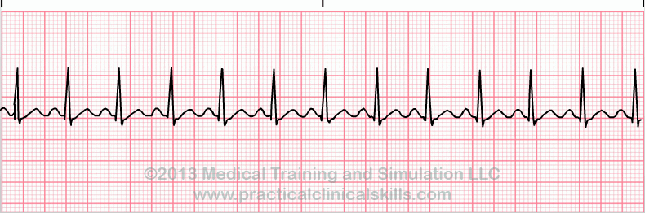

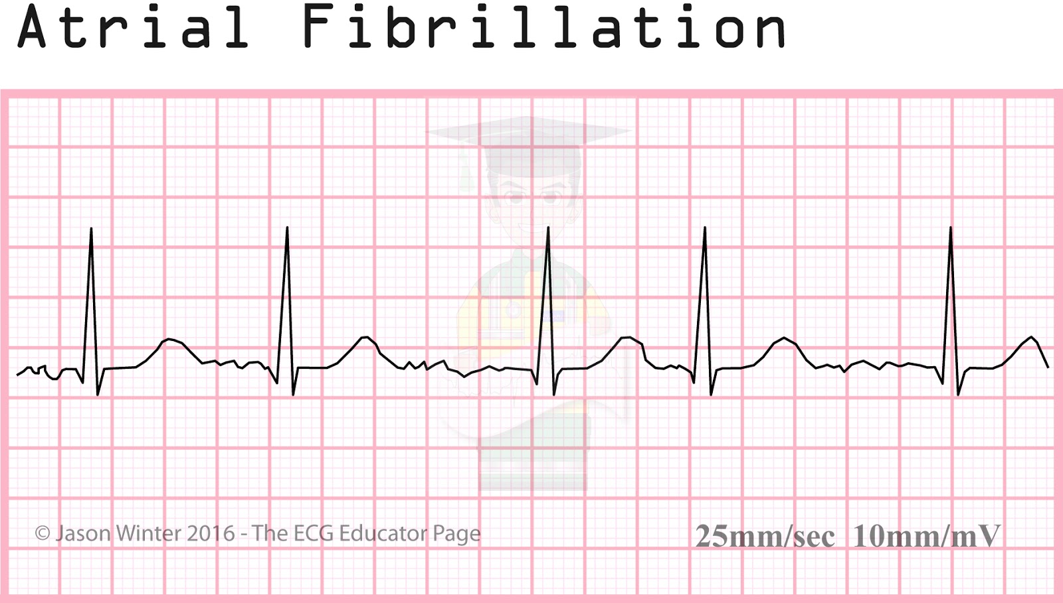

*Atrial Flutter

*Supraventricular Tachycardia
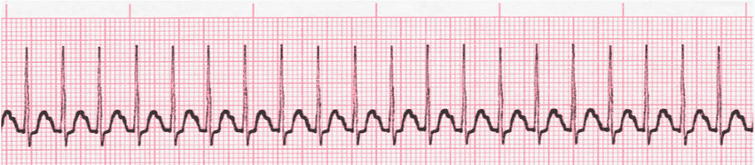

**VT
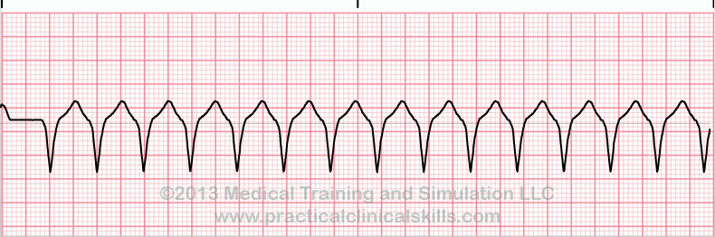

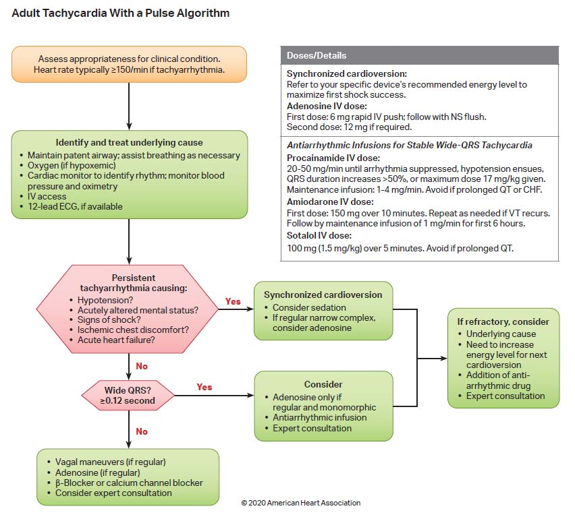

Bradycardia:
- Regular
    - Sinus bradycardia
    - Junctional bradycardia
    - Complete AV block (junctional escape)
    - Atrial flutter with high degree block
- Irregular
    - Sinus arrhythmia, pause or arrest
    - Sinoatrial exit block (second degree)
    - Atrial fibrillation with slow ventricular response
    - Atrial flutter with variable block
    - Second degree AV block, type I
    - Second degree AV block, type II

- Management
  - Get vitals first!!!
If unstable, manage per ACLS guidelines & see patient
- Go see the patient
New bradycardia? Symptomatic? dizzy, chest pain, syncope
  - Obtain EKG and compare it to old EKG
  - Questions to Consider
    - Medications: β-blockers, Calcium-channel blockers, digoxin, amiodarone, clonidine.
    - Recent blood draw, tunnel vision, & nausea? vasovagal?
    - Can be cough/micturition/emesis /defecation induced.
    - Are they having an MI?
    - Did they have a massive PE?
    - Do they have autonomic instability?
    - Do they have an infiltrating cardiac disease?
    - Do they have severe hypothyroidism?
    - Do they have increased intracranial pressure?

*Sinus Bradycardia
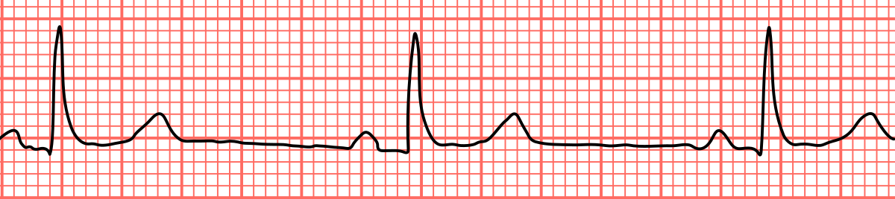

*Junctional Bradycardia

*Second Degree, Type 1 Heart Block
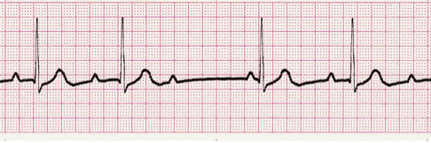

*Second Degree, Type 2 Heart Block
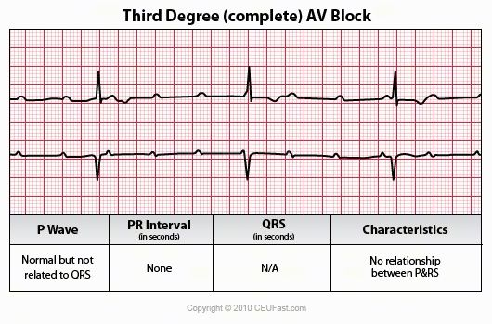

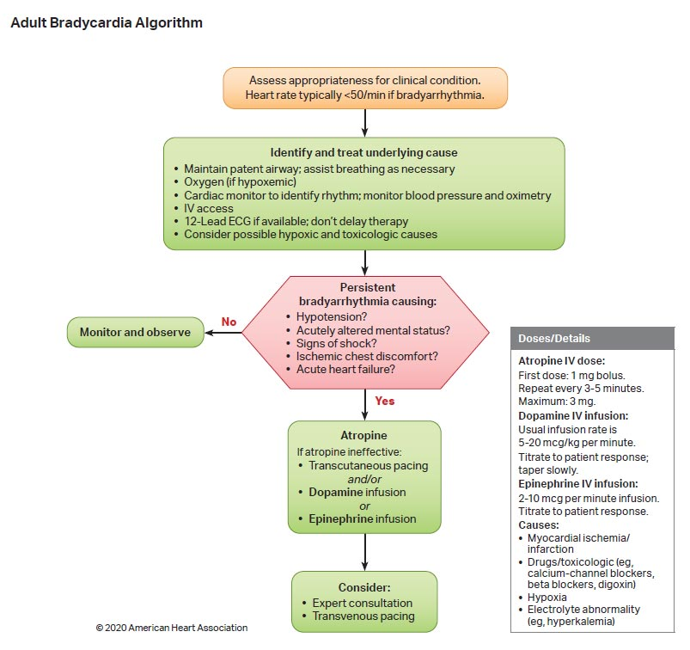

Nausea:
-Always consider ileus or SBO
-Chest pain and increased ICP patients can have nausea too.
-Common Rx:
    - Reglan: 5-10mg
    - Can stimulate gastric emptying
  - Can cause a dystonic reaction if chronically used.
  - Renally dosed
  - Recall QTc prolongation
    - Phenergan: 5-10mg
  - Well tolerated
  - Has a PR form.
  - Also, can prolong QTc
    - Compazine: variable
    - Serotonin antagonists (Zofran)
  - QT prolongation
  - Serotonin syndrome
    - If patient already on serotonergic drugs (linezolid), think twice

Pain
Mild-Moderate Pain (1-5)
- Acetaminophen and NSAIDS (not in renal disease, GI bleeders, or ACS pts) will usually suffice.
- Don’t forget to consider topical therapies including lidocaine patch, NSAID gels

Moderate to Severe Pain (6-10)
- Opioids in the right clinical context. Keep in mind that Acetaminophen and NSAIDs can be just as effective or even more so. If patients were not scheduled on Tylenol you can consider doing this as well
  - 2 gram Tylenol in significant liver disease
  - 3 gram otherwise
*Morphine not to be used with significant renal impairment. You may over sedate the patient due to lack of secretion of long acting metabolite. Consider Dilaudid, but use caution. START LOW IF YOU ARE UNSURE – YOU CAN ALWAYS GIVE MORE IF YOU NEED TO!
Opioid Equivalents
Opioid | Oral (mg) | IV (mg)
Morphine | 25 | 10
Hydromorphone | 5 | 2
Oxycodone | 20 | -
Hydrocodone | 25 | -
Codeine | 200 | -
Fentanyl | - | 150 MCG

Bowel Regimen:
Please order when you order opioids.
1. First try Senna PO; If that doesn’t work
2. PRN Miralax, Milk of Mag, dulcolax, mag citrate or Lactulose
NOTE: NOTHING FROM ABOVE IF SUSPECT Obstruction.
3. Suppository-dulcolax
4. Lastly the Enema: tap-water enema, tap water with soap suds, mineral oil, Fleet with phos (Not to be used in CKD/dialysis patient)

DO NOT FORGET TO R/O STOOL IMPACTION FIRST. (no rectal exams or suppository in neutropenic pts!)

Hypertension:
A. Hypertensive Emergency: IV meds
GOAL: Lower BP by 15-20% in 1st hour. NO MORE.
Consider: Arterial line and ICU admission.

**Recall special consideration with HTN relate due to cocaine intoxication or alcohol/benzo withdrawal

Some common IV gtt (drips) that you can use
- Esmolol
  - Great with CAD patients, tachyarrhythmias, aortic dissection
  - Rapid on/off
  - Large volume, very expensive
- Fenoldopam
  - Partial D1 agonist: good for renal dysfunction
- Hydralazine
  - Caution in acute coronary syndromes, CVAs, and dissecting aneurysm
- Labetalol
  - Alpha and non-selective beta blockade
  - Caution in patients with heart failure or restrictive lung disease.
- Nicardipine
  - CCB: vasodilation and decreases PVR
  - Caution in acute heart failure and coronary ischemia
- Sodium Nitroprusside
  - arterial/venous vasodilator, decreases preload and afterload
  - increases ICP, increases mortality if used in early AMI.
- Nitroglycerin
  - Good for pulmonary edema and acute MI

Hypertensive urgency
- Try short acting oral meds for easier titration.
- DBP usually > 130, SBP usually > 210 w/o signs of end organ damage.
-Back to normal BP in 1-2 days.

Non-Emergent Blood Pressure Elevations in the Hospital:
- Common to have HTN in the hospital; use caution with PRN BP medications as you may cause more harm than good when unnecessarily treating BP.
- Assess Pts Clinical scenario: i.e. recent stroke, limb ischemia, hypertensive emergency requires slow BP normalization
- Consider adding home meds, unless they were held for a reason?
- Can consider:
-Captopril
-IV or PO Hydralazine
-Labetalol

Hypotension:
- Are they Septic? Cardiogenic? Hypovolemic (bleeding/over diuresis)? Iatrogenic?
- What’s their Cardiac Ejection Fraction?
    - LVEF 30-40% or LESS consider only 250cc to 500cc boluses vs 1L with better EF
- Patients have variable “normal” blood pressures i.e. advanced heart failure, cirrhosis, autonomic dysfunction, spinal cord injury, fit/thin patient, etc.

** Patient’s legs contain ~ 250-500cc of volume. If blood pressure and HR improve w passive leg raise, consider giving them fluid.
-If patient is NOT responsive to fluid administration, may require pressers. Don’t hesitate to call ICU when appropriate!!
**Hold medications that may cause hypotension and medications that may prevent pressor function

Hypoglycemia (Add hypoglycemia protocol order):
Asymptomatic?
- Able to take PO?
  - 8 oz of juice is about 30 grams of carbohydrates
  - 2 graham cracker squares = 10 g CBH
  - For every 15 g carbs, expect blood sugar rise 25-50 mg/dL
- Unable to take PO- as below

Symptomatic (tremors, diaphoresis, palpitations) or NPO patient?
  - 1 Amp of dextrose IV. Or 1mg Glucagon IM
  - Follow blood sugar closely! Q 5 min to start.
  - Consider start D5 or D10 blood sugar >100

Hyperglycemia:
*Don’t forget hypoglycemia is significantly more dangerous than hyperglycemia. Move slow!
*Always use extra caution with ESRD patients
*Goal between 140-180
*Can start with Insulin sliding scale but ISS alone has been shown to worsen outcomes and should not be used alone. Patient should be converted to baseline and prandial insulin when appropriate

Ex.
Pre-meal BG | <40 units insulin/Day | 40-80 units insulin/day | >80 units insulin/day
150-199 | 1 unit | 2 units | 3 units
200-249 | 2 units | 3 units | 4 units
250-299 | 3 units | 5 units | 7 units
300-349 | 4 units | 7 units | 10 units
>349 | 5 units + call | 8 units + call | 12 units + call
*Supplemental scales should be proportional to total daily dose insulin.

Hyperosmolar Hypoglycemic State & Diabetic Ketoacidosis

HHS: Type 2 DM with illness or non-compliance with meds. Clinical presentation may range from fatigue to coma. Type 2 DM are resistant to insulin, however there is still enough insulin produced by the pancreas to prevent ketosis, therefore there is no ketone formation. The more pressing issue with HHS is hyperosmolarity which can result in hypertonic encephalopathy. These patients are markedly dehydrated and require massive fluid resuscitation.

DKA: Usually type 1 diabetics in scenario of infection or incorrect insulin dosing. May manifest initially as polyuria/polydipsia, dehydration and nausea/vomiting progressing to compensatory Kussmaul respirations, somnolence and eventual coma.

Monitoring
1) Glucose q1h
2) Electrolytes q2h (alternating BMP and VBG)
3)Neurologic status q2 hours

Considerations
1. DO NOT start insulin in the presence of severe hypokalemia
2. **K needs to be >3.3 **
3. ** Phos >1.5 to help prevent respiratory depression **
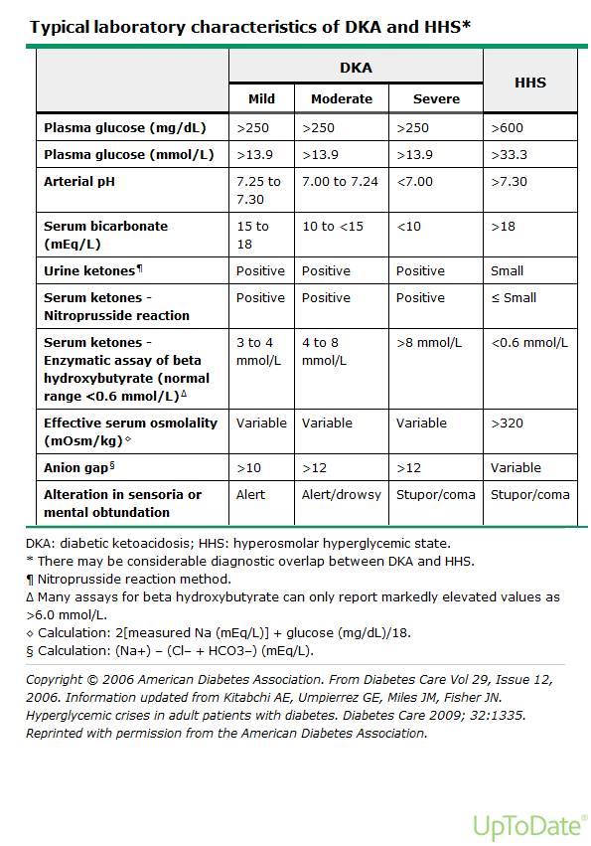
Please see the Corresponding Algorithms for HHS & DKA Below
(Can be found easily on UpToDate).

When to transition to subcutaneous insulin?
-anion gap is resolved
-bicarb is approx. >17
1. Give subcutaneous insulin (if naïve to insulin can start weight based at 0.5 units/kg, otherwise restart home dose)
2. Stop insulin drip and fluids 2 hours after long acting (glargine, NPH, detemir) subq insulin is administered

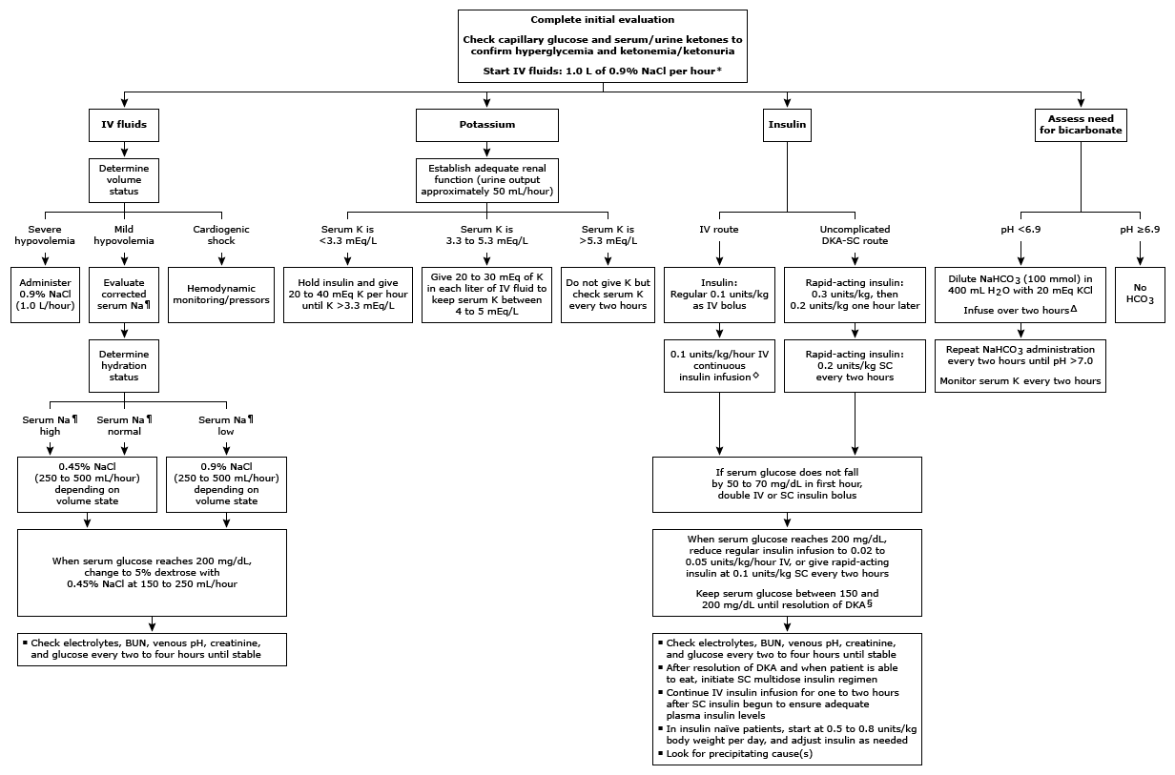
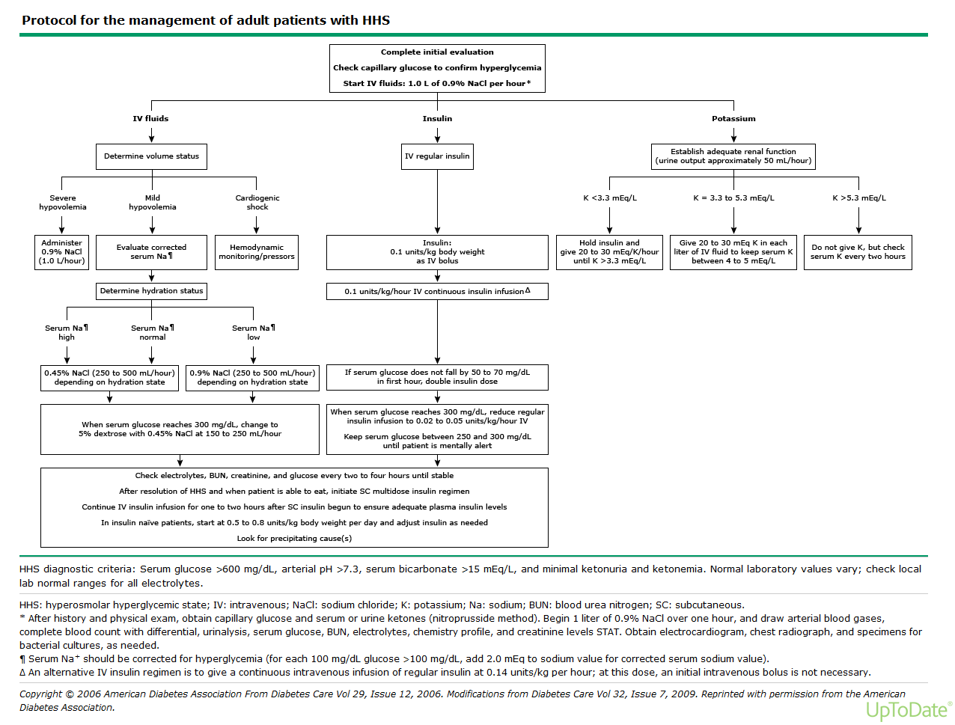

Altered Mental status (Acute Encephalopathy)
DDx: hypoglycemia, CO2 narcosis, med overdose, seizure, stroke, aspiration, sepsis, ICH, delirium, Hypothyroidism, wernicke korsakoff, etc.

- First step is always evaluate patient’s hemodynamics
  - ABCDs
Oxygen with oropharyngeal airway if necessary, NO ORAL AIRWAY IF PT HAS GAG STILL

- Evaluation
  - HPI, clinical evaluation with targeted therapies
  - Evaluate recent medications given to patient
  - POCT glucose
  - CBC, CMP Mg, PO4
  - VBG/ABG
  - Blood Cxs
  - TSH
  - Drug Screen
  - Chest X-ray
  - Urinalysis
  - Brain Imaging- if focal neurologic signs or risk for CVA
  - Consider LP especially if fever/meningeal signs/immunosuppressed
- Possible Treatment
  - Consider Abx as appropriate
  - D50, 1 amp after thiamine (100mg IV)
  - Naloxone, start low and titrate up 0.4-1.2 mg IV. Give even if opioid OD seems unlikely.
  - Can even dilute naloxone into 10cc of NS in order to make it easier to titrate
  - Lift head of BED (for increased ICP) and aspiration risks.
  - BiPap – cannot do this without pulmonary/ICU, also cannot use if too altered
  - Thyroxine
  - Target to appropriate therapy

Seizures:
- Real versus Pseudo
  - Neurological examination
  - O2 by face mask/Nasal Cannula
  - position Pt. on side/semi prone to prevent aspiration. Suction PRN.
- If seizures continue after 2-3 minutes, Ativan 2 mg followed by another 2 mg if no response. Alternatively, Ativan IM Q5 minutes to max 8mg can also be done.
- some guidelines consider pheny or fospheny with Ativan if seizures do not break
  - Don’t forget to CHECK GLUCOSE as reversible cause
Give thiamine 100 mg IV first, then 1 amp D50 IV
  - Don’t forget to check sodium to ensure patient does not have severe hyponatremia
Sodium Chloride 3% given 100ml Q10min X 3
    - Seizure >5-10 mins think status epileptics and call ICU early.
Call neuro to help determine loading med
    - Keppra, phenytoin. Etc..

Chest Pain:
DDX
Cardiac/Aortic
  - ACS
  - Prinzmetals Angina
  - Drug intoxication
  - AS
  - Aortic Dissection
  - Pericarditis
Pulmonary
  - PE
  - Pneumonia
  - Pleuritis
Gastrointestinal
  - GERD
  - Diffuse esophageal spasm
  - Esophagitis/gastritis
  - Acute cholecystitis
  - Pancreatitis
  - Peptic ulcer disease

***always consider diagnosis that can kill the patient first: ACS, Aortic Dissection, PNA, PE, abdominal viscus rupture

** Questions to assess for “typical chest pain”
- Retrosternal?
- Improved by nitroglycerin?
- Worsened by activity?
  - 3/3= typical chest pain
  - 2/3= atypical chest pain
  - 0-1/3=non-cardiac chest pain **can still be cardiac in nature

Management
  - ECG STAT. Wait at the side of the bed for the EKG! Make sure to compare to old EKG
STEMI?- call senior/fellow/attending. You have 90 minutes!
  - Get troponins stat and every 6 hours or until they peak and trend down.
  - Consider obtaining chest x-ray
  - Nitro Sub Lingual q 5 min (if Blood pressure is too low can try IV morphine 2-4 mg, Start low)
May need fluids if right ventricular infarction
  - ASA full dose and have patient chew tablet.
  - Consider starting medications that reduce cardiac work
B-Blocker/CCB
Ace-I
  - Heparin gtt
  - If TIMI score is moderate or high risk consider Plavix load. Plavix load may delay CABG. Consider cardiology discussion. Rarely use G3B/2A inhibitors here but should be considered with high risk patients

Shortness of Breath/Respiratory Failure:
**Also see ICU Respiratory Failure for a more comprehensive overview

DDX
Reactive airway
PE
Fluid overload
Transfusion Rxn
PNX
ARDS
Aspiration,
etc.

Oxygen: Your goal is O2 sat > 88%

Therapies
- Start with O2 via nasal cannula (tubes in the nose), venturi mask (clear mask over nose and mouth), or non rebreather (clear mask w bag).
  - Nasal cannula:
Low Flow: 1-5 L/min: 20-40%
High Flow: up to 8L/min delivers FiO2 up to 38%
(careful in Hypercapnic patients, not recommended)
- Venturi can deliver 35-55% FiO2 @ 6-10L
- Nonrebreather can deliver 100% FiO2
****If on venturi or nonrebreather then immediately notify ICU ****

- *Beta agonists
- Albuterol continuous, Q1H, Q2H etc.
- Duo-Nebs
- Steroids: Usually for Asthma/COPD
- *Diuretics: if appropriate,
check I/Os. Can start with Lasix 40mg IV (don’t forget to adjust for renal function!). WATCH urine output..
  - If no urine output, check bladder scan, if bladder is empty, then double Lasix dose; If bladder full insert Foley or straight cath.

Advanced Therapies – INVOLVE PULMONARY FELLOW!!!!
**BiPAP can buy you time and may prevent intubation, especially in COPD exacerbation and heart failure patients. However, multiples studies have shown that BiPap for other reasons may increase mortality/morbidity by delaying appropriate intubation
**contraindications - inability to protect airway, severe metabolic disturbance, arrhythmia, severe hypotension, upper airway trauma, facial trauma, inability to get good seal on mask, recent esophageal Sx

**GOOD INITIAL BIPAP STARTING Settings: IPAP:15 or 12 EPAP: 5 at Fio2 100%
-Decrease as tolerated based on ABG or sat >88%

*************** Critical Concepts *****************
Need to get rid of CO2? Increase the IPAP and EPAP pressure difference
- (IPAP – EPAP = Tidal volume). You can increase the RR as well.
  - **Recall CO2 removal is dictated by Minute Ventilation (TvXRR)

Need to improve O2 delivery? increase EPAP (PEEP) and FIO2;
*Remember to increase IPAP equally otherwise you lose Tidal volume!!
*Try and avoid increasing IPAP >20 as the stomach may rapidly inflate and induce vomiting
*********************************************************

ASTHMA/COPD Exacerbation:
- Oxygen supplementation
-O2, if needed, should be tailored to achieve a pulse ox ~ 92%
-NOTE: High flow O2 use for treatment of pure asthma exacerbation is associated with increased mortality.
- Bronchodilators:
-Beta Agonists – Albuterol: No significant difference between MDI and Nebs. Can do continuous nebs if need in short term, watch for tachycardia.
- Anticholinergic – Ipratropium (DuoNeb: albuterol/ipratropium)
- Steroids – 5 day bursts ok W/O taper for asthma. However, multiples studies have shown COPD likely needs longer tapers from 8-14 days depending on severity. Remember if pt comes in on steroids they will likely need to bump him up on his dose.
- -Magnesium – 2g magnesium sulfate only has a benefit in severe exacerbations.

Comfort Care Medications
**There is a comfort care order set available
**These are only guidelines, you must take into account patient’s opiate tolerance
- Dilaudid 0.5mg SQ q1h PRN pain
- Oxycodone 5-10mg q3-4hrs PO PRN pain
- Versed 2mg SQ q4h PRN anxiety
- Lorazepam 0.5mg PO q4h PRN anxiety
- Morphine nebs 10mg q4h PRN respiratory distress (may mix with albuterol/atrovent)
- Morphine 1-2mg q2h SQ PRN respiratory distress
- For respiratory rattling
  - Atropine 1mg SQ q4hr PRN
Glycopyrrolate 0.6mg nebs q4hrs PRN

Electrolytes
Below are suggestions for electrolyte replacement but each clinical scenario may differ. When in doubt, please check with your senior.

Potassium:
Hypokalemia: K <3.5mEq/L
Causes | Complications | Therapy
-inadequate intake  -vomiting/NG drainage  -diarrhea  -diuretics  -hypomagnesemia  -Cushing’s syndrome  -Alkalosis  -Insulin  -Beta-adrenergic agents | -muscle weakness  -cramps  -tetany  -polyuria/polydipsia  -orthostatic hypotension  EKG: flattening of T waves, U wave development | IV: 10mEq/hr for peripheral IV K+, <20-24mEq/hr through central line. Max of 40meq/hour  Oral KCl 20-40 mEq BID-TID  -Treat hypomagnesemia  **caution with patient’s with increased Cr

Serum K | mEq KCl to give PO/IV (Goal of 4.0)
3.7 to 3.8 | 20
3.5 to 3.6 | 40
3.3 to 3.4 | 60
3.1 to 3.2 | 80
< 3.0 | 100
10mEq of KCl will raise K levels by 0.1

**Important considerations
-10mEq of KCL will not raise K levels by 0.1 if the potassium is severely depleted. You may end up giving 10-40mEq of KCL to raise it by 0.1
-please be careful giving patient’s with CKD/ESRD potassium IV as they will not be able to autocorrect. Oral KCL can be substituted and works well with better auto correction.

Hyperkalemia: K >5.2mEq/L
Causes | Complications | Therapy
-Inadequate renal excretion of potassium  -Acidosis  -Renal Failure  -volume depletion  -Hypoaldosteronism  -Hemolysis  -Drugs which block RAAS: ACEi, K sparing diuretics, NSAIDs, heparin, TMX/SMP, pentamide  -Massive Transfusions | -Weakness  -Flaccid paralysis  -Confusion  -Hyperactive DTRs  EKG: peaked T waves (usually in V2 and V3), widened QRS, loss of P wave, asystole  -Vfib (K >8) | Review meds - stop any iatrogenic causes  -Calcium gluconate or chloride – give IV over 3 minutes. This will help to stabilize cardiac membrane, give when EKG changes  SHIFT  -10 units regular insulin IV with 1 amp of D50  -sodium bicarb  EXCRETE  -kayexalate vs lokelma  -diuretics (Lasix)  -dialysis

Magnesium:
Serum Mg | gm of MgSO4 to give IV (goal of 2.0)
1.8 to 1.9 | 1g
1.6 to 1.7 | 2g
1.4 to 1.5 | 3
1.2 to 1.3 | 4
< 1.2 | 5
Give each gram over one hour

Options for oral replacement:
Drug | Dose per tablet | Typical dose
Mg Oxide | 420 mg | 1 to 2 tab qd
Mg gluconate | 500 mg | 1 to 2 tab qd

Calcium:
Hypocalcemia: Ca <8.4
Corrected Calcium = [0.8 x (4.0 – serum albumin)] + serum Ca
Causes | Complications
-Hypoalbuminemia  -Sepsis  -PTH deficiency  -Vitamin D deficiency  -Hyperphosphatemia  -Pancreatitis  -Osteoblastic metastases  -Massive transfusion  -Hypomagnesemia | -Hypertension  -Peripheral and perioral paresthesia  -Abdominal pain  -Lethargy  -Hyperreflexia  -Trousseau’s sign  -Positive Chvostek’s sign  -Seizures/tetany  - EKG: prolonged QT interval

Serum Ca mg/dl | Replacement | Notes
Symptomatic - or -  Asymptomatic <7.5 | IV Ca-Gluconate 1-2 g +/- infusion | Gluconate preferred due to reduced risk of tissue necrosis
7.5-8.0 | 1500-200mg Ca-carbonate or citrate in divided doses

Hypercalcemia: Ca >10.2
Causes | Complications | Therapy
-Hyper-parathyroidism  -Malignancy  -Sarcoidosis  -Renal failure  -Thiazide diuretics  -Milk-alkali syndrome  -Exogenous intake | -stones, bones, moans, groans = renal colic, osteitis fibrosa, constipation, confusion  -polyuria/polydipsia  -fatigue  -anorexia  -nausea/vomiting  -hypertension  -hyporeflexia  -mental status changes  EKG: shortened QT interval | -Saline diuresis: D5NS @ 250- 500ml/H  -Lasix 40mg IV q2h to a goal UO of 100-200mL/minute (this volume must be replaced with NS)  -Chronic: calcitonin, corticosteroids, pamidronate, plicamycin, dialysis

Sodium:

Hyponatremia: Na <135mEq/L
Symptoms: Lethargy, Confusion/coma, mental status changes Muscle twitches/seizures Nausea/vomiting, Hyperreflexia ARDS

Hypoosmolar  Hyponatremia | Hypervolemic | Euvolemic | Hypovolemic
Causes: | -CHF  -Nephrosis  -Renal Failure  -Cirrhosis/Liver dz | -SIADH  -hypothyroidism  -psychogenic polydipsia  -adrenal insufficiency | -renal loss/diuretics  -vomiting/diarrhea  -third spacing  -Addison’s disease
TBW  TBNa | ↑↑  ↑↑ | ↑  -- | ↓↓  ↓
PE  Lab | Peripheral Edema  UOsm High  UNa High | Lethargy, seizure  Renal: UOs Low  Non: Uosm High | Orthostatic, hypoTN  Renal: UOs High, UNa high  Non: UOsm High, UNa low
Treatment: | Water restriction, Diuretics/Dialysis | -H20 restriction  -treat underlying cause  -refractory +/- demeclocycline | -replace with NS
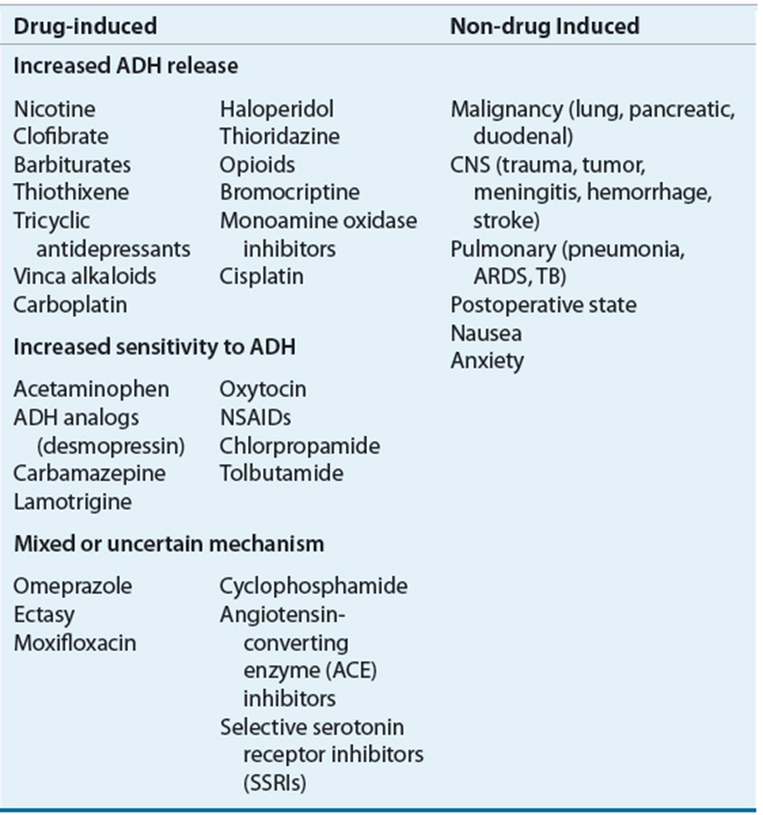

EVALUATION
STEP 1: If hyperglycemia, Corrected Na = [Na]_{serum} + [1.6 x [glucose -100)/100]]. If sodium is normal, hyperglycemia induced

STEP 2: Hyperosmolar v. iso-osmolar v. hypoosmolar
a. lipemic or plasma cell dyscrasia?
i. Direct potentiometry sodium OR measure total protein and/or lipids à elevated à pseudohyponatremia
b. Low (hypo-osmolar). Proceed to step 3

STEP 3: Volume Status
a. Hypervolemic: due to low effective arterial blood volume
i. Heart failure v. Cirrhosis v. Nephrosis
b. Euvolemic/Hypovolemic: Measure Urine Osm and Urine Na
a. UNa <40 OR UOsm <100 = Hypovol. HypoNa
b. U Na >40 and U Osm >100 = Euvol HypoNa
c. Measure TSH and AM cortisol

IF SYMPTOMATIC HYPONATREMIA – discuss management with your senior/attending. May require ICU evaluation.

*Initiate 3% NaCl (hypertonic saline) to quickly correct Na if seizing or coma

** optimal rate of correction is 4-6mEq/L in 1st 24hrs. Na should not be corrected >10 mEq/L in 1st 24hrs or more than 18mEq/L in 48hrs as this places patients at risk to develop central pontine demyelinosis.

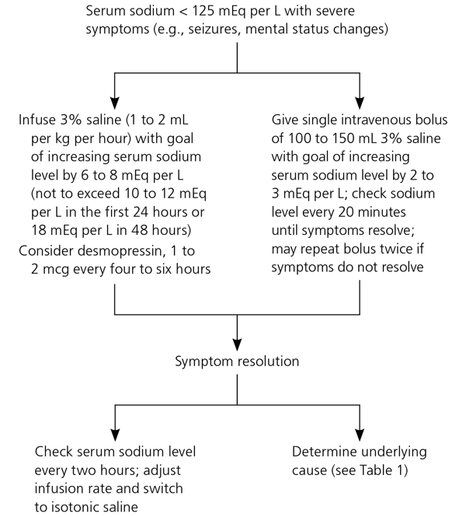

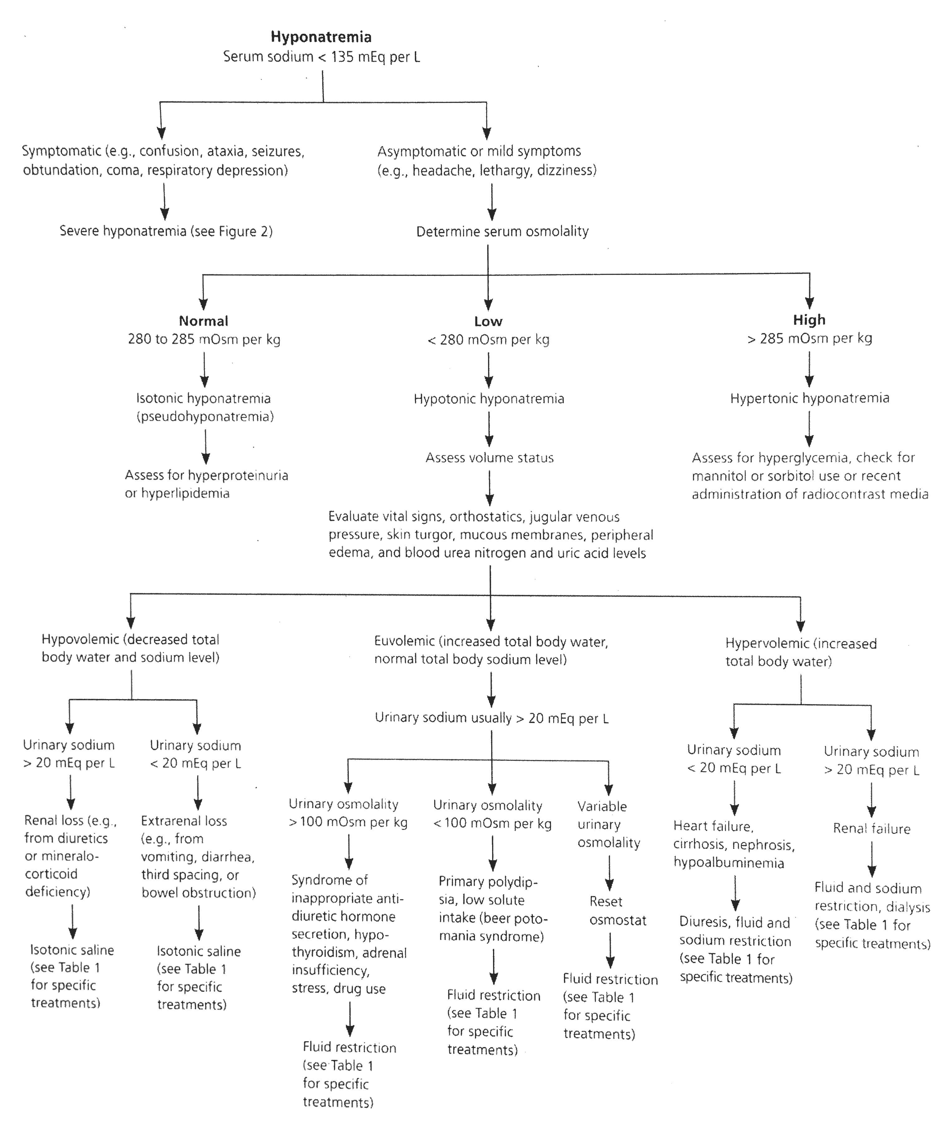

Hypernatremia: Na > 145mEq/L
Free water deficit (L) = $\frac{0.6 x Wt \left(kg\right)x \left(Serum Na – 140\right)}{140}$

Causes | Complications | Therapy
-osmotic diuresis  -diabetes insipidus  -Cushing’s syndrome  -hyperaldosteronism | -confusion  -lethargy  -stupor  -seizures/coma /altered mentation | Hypovolemic: Rehydrate w/ NS:  Euvolemic:  -Calculate and replace water deficit: administer as D5W or ½ NS  -Give ½ volume in 1st 24 hrs and remaining in the following.  Hypervolemic: Lasix +/- D5W

Phosphorous
Hypophosphatemia: <2.5 mg/dL
Causes | Complications | Therapy
-intestinal malabsorption  -chronic diarrhea  -vitamin D deficiency  -starvation/anorexia  -alcoholism  -Fanconi’s syndrome  -severe burns  -post feeding syndrome  -respiratory alkalosis | -muscle weakness  -hemolysis  -rarely develop neuro disorders | Acute: replace with IV  -Kphos: 3mmol/ml of phos; 4.4 mEq/ml of K  -Na phos: 3mmol/ml of phos; 4.0 mEq/ml of Na  Preferable method: replace PO  -milk  -Neutraphos K capsules: 250mg/ capsule with max dose of 3 tabs q6h  -Neutraphos solution: 128mg/mL

Serum Phos | IV K-Phos or Na-Phos | Oral
2.0 to 2.5 | 15 mmol | 1 mmol/kg/day in divided doses
1.0 to 2.0 | 21 mmol | 1.3 mmol/kg/day in divided doses
*IV: 15 mmol K-Pho = 22 mEq K+ & 15 mmol Na-Phos = 22 mEq Na+

Hyperphosphatemia: >4.5 mg/dL
Causes | Complications | Therapy
-increased intestinal absorption  -ESRD due to decreased renal excretion  -Tumor lysis syndrome  -hemolysis, rhabdomyolysis  -hyperthermia | Usually asymptomatic.  -symptoms mostly occur from concomitant hypocalcemia | -volume expansion (fluids)  -dialysis  -oral phosphate binders (calcium carbonate, calcium acetate or sevelamer carbonate)

INTRAVENOUS FLUIDS
Crystalloids: does not remain in the intravascular space, resuscitative volumes will cause interstitial hypervolemia that resolves over 3-4 days.

Fluid | Glucose | Na | Cl | K | Ca | Mg | Osmolality  (mOs/L)
Plasma | 80-100 | 141 | 103 | 4-5 | 5 | 2 | 289
3% NS |  | 513 | 513 |  |  |  | 1026
NS |  | 154 | 154 |  |  |  | 308
½ NS |  | 77 | 77 |  |  |  | 154
Normosol |  | 140 | 98 | 5 |  |  | 295
LR |  | 130 | 109 | 4 | 3 |  | 273
D5W | 50 |  |  |  |  |  | 278
D10W | 100 |  |  |  |  |  | 556
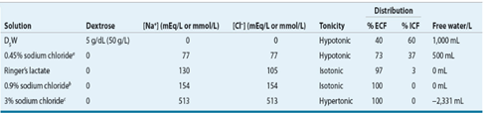

Colloids
Colloids replace plasma volume. The most commonly used colloid is 5% albumin derived from human plasma. Its oncotic pressure and activity is similar to that of plasma. About half of the infused amount remains intravascular with the effect lasting 12 – 18 hours. Albumin is also available in a 25% preparation used for rapid volume expansion in hypoproteinimic individuals by drawing the interstitial fluid into the vascular space. Other colloids such as have not been shown to be beneficial in Sepsis

Colloid | Concentration | Colloid osmotic pressure | Duration of effects
5% albumin | 50g/L | 20mmHg | 12-18 hours
25% albumin | 250g/L | 70mmHg | 12-18 hours

Infectious Disease
Approach to Fever in the ICU:
-Fever is defined as a temp >100.4◦F
- Investigation for source should be done:
“Pan-culture” frequently finds colonization. Therefore consider:
-Two sets of blood cultures from 2 different sites
-Chest radiograph
-Sputum for gram stain and culture
-Examine line sites for signs of infection. If there is erythema and existing access permits, remove the catheter
-Start antipyretic therapy
-If the patient is immunocompromised or has signs of sepsis, start empiric therapy to cover gram negatives and any suspected gram-positive organisms
Do not repeat cultures on a schedule or if recently obtained.

Common causes of nosocomial fever:
-sinusitis
-pancreatitis
-catheter sepsis (urinary, central lines)
-translocation
-drug fever
-enterocolitis
-wound infection
-bowel infarction
-pneumonia
-urosepsis
-pulmonary embolism
-DVT
-MI
-acalculous cholecystitis
-endocarditis
-perforated ulcer

Line Infections:
- Occur by seeding of the catheter tip by local flora at the insertion site or sterile technique failure during maintenance.
- Most common organisms: Staph epidermidis, then Staph aureus & GNRs.
- May present as fever of unknown origin with or without evidence of local infections (i.e. erythema).
- If a line infection is suspected, catheter should be removed. Vascular access may be limited requiring continuation of line. If so, start empiric therapy, and obtain a culture from the suspected catheter and another from a distant site.
- If the colony count of suspected line culture = at least 3x distant site culture or line culture positive 2 hours before peripheral a line infection is presumed.
-Typically, peripheral IV lines should be changed every 3 days. An arterial line should be changed or removed if line infection is suspected.

Antibiotics:
1.Vancomycin (IV) - always consult pharmacy for dosing: bacteriostatic
All GRAM POSITIVES – except VRE
- Staphylococcus, vancomycin sensitive enterococcus
- Strepotococcus (including S pneumo)
- Gram positive rods (C Diff – only time PO vanc is used)
- NO GRAM NEGATIVE coverage
Need to monitor trough levels, drawn 30 minutes in 48 hours of initiation, typically prior to the 4th dose.
- Goal is usually 15 – 20 (especially for pneumonia, bacteremia)
- If continuous infusion, goal is 20 – 30 Adverse effects:
- Red Man Syndrome: not a true allergic reaction. Give Benadryl, H2 blocker and slow down rate of infusion
- Nephrotoxicity: need to monitor trough levels to prevent this. Usually occurs when used with other nephrotoxic agents

2.Telavancin – approved for cellulitis in 2009, and recently improved for HAP/VAP in 2013
- More bactericidal than vanc
- More nephrotoxic than vanc, teratogenic, may prolong QT, interferes with INR testing
- No bacteremia trials.
- Would only use as salvage therapy with the recommendation by ID

3.Penicillins
A. Penicillin G (IV) or Penicillin VK (PO)
- Reliably kills Streptococci (except S pneumo)
- Neisseria meningitides, syphilis
- Cheap and very bactericidal
B. Oxacillin/Nafcillin (IV), Dicloxacillin (PO)
- Ox/Naf achieve a higher serum concentration than PO form
- Narrow spectrum – destroys staph and strep
  - Misses MRSA, gram negatives
- Most bactericidal agent against susceptible MSSA
- Drug of choice (DOC): Endocarditis, Ostemomyelitis if MSSA has been cultured
C. Ampicillin IV, Amoxicillin PO
- Susceptible to beta-lactamase
- Broader spectrum than PCN G and Oxacillin
- Covers certain gram negatives
- Misses: staph 95% of the time (If resistant to PCN than can’t use Amp or Amox)
- Use: otitis media, bronchitis, sinusitis, UTI
- DOC: Enterococcus (if sensitive)
D. Augmentin (PO) and Unasyn (IV)
- Broader spectrum due to beta lactamase inhibitor
- Covers many gram + and gram – and anaerobes
- Misses: MRSA, pseudomonas, atypical
E. Zosyn (piperacillin-tazobactam) IV only
- Broad Coverage
- Covers: Gram +, gram – (including pseudomonas), anaerobes Enterococcus (if sensitive to ampicillin)
- Misses: MRSA, VRE, atypical
Gram negatives with an extended spectrum beta-lactamase (ESBL)

4. Carbapenem (IV Only) – some cross reaction in PCN allergies, avoid if possible
A. Meropenem/Imipenem
- Almost same coverage as Zosyn, but less resistance (can use for ESBL)
- Tends to promote resistant organisms. Don’t use unless absolutely needed
- Imipenem can cause seizures
B. Ertapenem
- Not as broad.
- Misses: pseudomonas, enterococcus, Acinetobacter
- Advantage: once a day

5.Aztreonam (IV Only)
- Expensive
- Ok to use in PCN allergic patients (this is its only use really)
- Covers: only gram negatives, including pseudomonas

6.Cephalosporins
A. 1st generation
- Cefazolin (Ancef) and Cephalexin (Keflex)
- Similar to nafcillin
- Ancef – primary surgical prophylaxis
B. 2nd generation
- Cefuroxime, Cefaclor: similar to Amoxicillin
- Cefotetan, Cefoxitin – also kills anaerobes, give for surgical ppx prior to abdominal surgeries
C. 3rd generation
1. Cefotaxime, Ceftriaxone
- Covers: Gram + (S pneumo), more gram negative coverage
- Misses: MRSA, enterococcus, pseudomonas, anaerobes or atypicals
- Penetration: these both cross the blood brain barrier
- USE: community acquired pna (in combination with azithro), meningitis, pyelonephritis
- Ceftazidime: kills pseudomonas. Usually use Cefepime due to high resistance
D. 4th generation
Cefepime (IV)
- Very broad spectrum; Good for gram -, gram + and pseudomonas
- Misses: anaerobes, atypicals and enteroccous
- Used to treat neutropenic fever, gram neg infections, pseudomonas
E. 5th generation
Ceftaroline (IV): Only beta lactam that covers MRSA
- Approved for cellulitis and CAP

7.Fluoroquinolones (PO and IV)
- Always try to use PO – near 100% bioavailability
- Not good for staph aureus – usually don’t use for staph aureus bacteremia, even if the organism is susceptible
Moxifloxacin
- Excellent for S pneumo, most gram – and atypicals. Decent gram +
- Misses: pseudomonas, MRSA
- Does not penetrate urine well – do not use for UTI or pyelo
Levofloxacin
- Similar to moxi, except this covers pseudomonas at 750mg Qd dosage
Ciprofloxacin
- Not as good for S pneumo,
- Best fluoroquinolone for pseudomonas, gram neg and urine infections

8.Macrolides: be careful with drug interactions
Azithromycin (PO and IV)
- Very long half life – therapeutic for appro 7 days after stopped
- Covers: strep pneumo, atypicals, some gram –ve
- Used to treat bronchitis, otitis media, pneumonia
Clarithromycin (PO and IV)
- Similar to azithro but dosage is BID

9.Clindamycin
- Covers: anaerobes, staph strep
- Misses: Gram negative coverage
- Used to treat aspiration pneumonia, anaerobic infections
- Increasing resistance (esp to strep)
- May decrease toxin production in severe strep/staph (i.e cellulitis)
  - Will use higher dose for toxic shock syndromes and necrotizing fasciitis

10.Aminoglycosides (IV only)
Gentamicin, Tobramycin, Amikacin
- Cover: Gram negative (including pseudomonas)
- Has synergy with PCN against staph and enterococcus
- Misses: gram + and anaerobes
- Mostly used in CF patients
- Watch for ototoxicity and nephrotoxicity

11.Bactrim (PO and IV)
- Covers: some gram + and some gram –, good for MRSA
- Misses: pseudomonas, anaerobes, group A strep
- Uses: simple UTIs, bronchitis, PCP
- Bacteriostatic – don’t for bacteremia or endocarditis
- Not great as single agent for cellulitis if used for cellulitis: use 2 DS tabs BID and add strep coverage
- Side effects: rash, drug rxn, bone marrow suppression, nephrotoxic, hyperkalemia

12.Tetracyclines: Do not use with pregnancy
Doxycycline (PO and IV) and Minocycline
- Cheap
- Covers: Very good gram +, MRSA, atypicals, some enterococcus, and kills rickettsia, borrelia, coxiella, etc
- Bacteriostatic: not good for MRSA bacteremia

13. Metronidazole (Flagyl) PO and IV
- 100% bioavailability
- Covers: Outstanding anaerobic coverage, good tissue penetration; Kills giardia, Entamoeba, trichomonas
- Misses: gram + & gram – coverage

14.Daptomycin (IV Only)
- Covers: resistant gram + organisms (MRSA, VRE)
- Bactericidal
- Very Expensive
- Not a good antibiotic for pneumonia because deactivated by surfactant
- Rhabdomyolysis is a side effect, must monitor CK weekly and DC statins

15.Linezolind (PO and IV)
- Covers: all gram + organisms
- 100% bioavailable
- Bacteriostatic – not recommended for endocarditis
- Expensive
- Causes pancytopenia (esp. thrombocytopenia), optic neuritis, neuropathy
- Can also cause Serotonin Syndrome, caution with other meds

16.Colistin (IV only)
- Only use again pseudomonas that are resistant to everything
- Normally used in CF patients
- Causes acute renal failure

Pneumonia - Lung infection caused by bacteria, virus or fungi
CAP (community acquired pneumonia): non-hospitalized patient w/o extensive healthcare contact
Most common pathogens: S pneumonia, Haemophilus influenza, Moraxella catarrhalis, Mycoplasma pneumonia, Chlamydia pneumonia and Legionella sp.
- viral infection or influenza (during heightened season)
-Must think of cocci as well
-Treatment:
-Levofloxacin or moxifloxacin
-Ceftriaxone + azithromycin
-Unasyn + azithromycin
-tamiflu (if concern for influenza)
-fluconazole (if concern for cocci)

HAP (hospital acquired pneumonia): develops > 48 hours after hospitalization
VAP (ventilator-associated pneumonia): >48 to 72 hrs post endotracheal intubation
With HCAP, HAP and VAP, concern for infection with MDRO, MRSA and pseudomonas. Therefore, therapy should be aimed to target these pathogens.

Treatment:
-MRSA: Vancomycin or Linezolid
-anti-pseudomonal: Zosyn, Cefepime or Cipro
**if Cefepime is the drug of choice and there is concern for aspiration, Flagyl should be added**

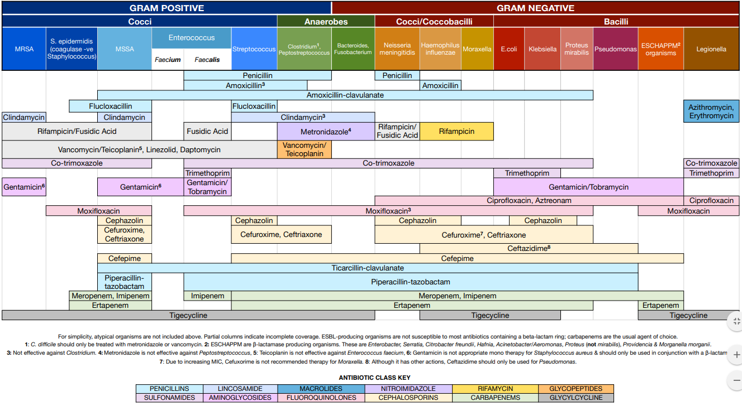

Sepsis
Life-threatening condition that arises when the body’s response to an infection injures its own tissues and organs. Sepsis mortality can be up to 40%. Rapid identification and therapy initiation is extremely important.
We have always defined sepsis by first using the SIRS criteria and expanding on that based on the severity.

SIRS Criteria: must meet 2 or more of the following to meet SIRS criteria
a. Temperature >38C or <36C
b. HR >90bpm
c. RR >20 breaths/min or pCO2 <32
d. WBC >12,000/mm3 or <4000/mm3 or >10% bands Sepsis: SIRS + suspected infection

Severe sepsis: Sepsis + organ dysfunction, hypoperfusion or hypotension, lactate >4mmol/L; SBP <90 mmHg after IVF
Septic Shock: persistent hypotension requiring the need for vasopressors to keep MAP >65

In February 2016, new guidelines were published to define sepsis.
Singer, M et al. The third international consensus definitions for sepsis and septic shock (Sepsis-3). JAMA 2016; 315(8): 801-810

The conclusion is that patients with suspected infection likely to have a prolonged hospital stay can be identified at the bedside using qSOFA

qSOFA (quick SOFA) criteria
RR >22/min
Altered mentation
SBP <100 mmHg

The following is a flow chart for diagnosing sepsis/septic shock:

Treatment for Sepsis:
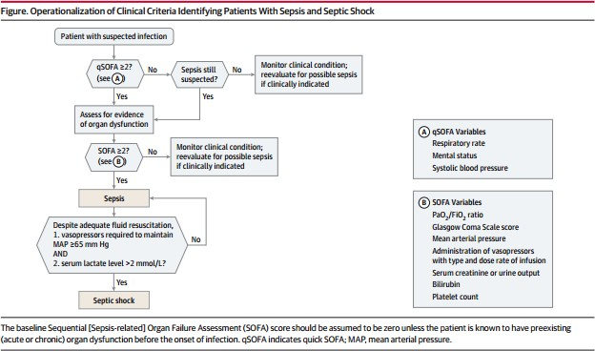
(*) Treatment for Sepsis is time sensitive. Fluid administration, cultures, initiation of antibiotics and lactate checks are monitored by the CMS. Mortality increases by about 6% for every hour of antibiotics delayed.
- Fluid resuscitation: 30cc/kg in form of NS or LR (use caution in HFrEF, ESRD, Cirrhosis)
**goal is to reduce the lactate 20-50%
- Pan-culture: blood culture x 2 separate sites, urinalysis, sputum culture (if producing sputum)
- start broad spectrum antibiotics
- hypotensive despite adequate fluid challenge (as per above) place central line and start vasopressors to maintain MAP >65
- ScVO2 from central line
-if ScVO2 is <70 consider inotrope if depressed EF on bedside echo or transfuse RBC if indicated
- Lactate q2-4 hours until normalizes

During all the above, every attempt should be made to control source of infection. This should be done by
1. Antibiotics
2. if abscess - needs drainage either by surgery or IR
3. if nec fasc, wound, etc – needs eval for surgical debridement

Adequate Fluid Resuscitation can be reassessed by the following:
1. passive leg raise test
2. bedside ultrasound
3. pulse pressure variation (PPV) per aline tracing
4. CVP (central venous pressure) – not routinely used

It is important to document as such:

Reassessment after Initial Fluid Resuscitation:
Date/Time:
Vital Signs:
Cardiovascular: (regular, irregular, NSR, tachycardia, bradycardia, JVD)
Pulmonary: work of breathing (improved, worsen, unchanged)
Capillary Refill: *** seconds
Skin: (normal, pale, diaphoretic, mottled, cool, warm, ***)
Pulse: (normal, bounding, thready, ***)

Reassessment after Initial Fluid Resuscitation:
Date/Time:
-CVP (N/A, *** mmH2O)
-ScvO2 (N/A, ***%)
-Bedside cardiovascular ultrasound (N/A, < 50% IVC respiratory variation, > 50% IVC respiratory variation,***)
-Dynamic assessment of fluid responsiveness with passive leg raise or fluid challenge (fluid responsive, not fluid responsive)

Hemodynamic Parameters

Parameter | Equation | Normal Range
Mean Arterial Pressure (MAP) | SBP + (2 x DBP)/3 | 70-105 mmHg
Systolic Pressure Variation (SPV) | (SPmax-Spmin) | <5mmHg – unlikely to be preload responsive  >5mmHg – likely preload responsive
Stroke Volume Variation (SVV) | (Svmax-Svmin)/[(Svmax + Svmin)/2] x 100 | <10% - unlikely to be preload responsive  >13-15% - likely to be preload responsive
Cardiac Output (CO) | HR x SV/1000 | 4-8 L/min
Cardiac Index (CI) | CO/BSA | 2.5-4 L/min/m2
Stroke Volume (SV) | CO/HR x 1000 | 60-100 mL/beat
Stroke Volume Index (SVI) | CI/HR x 100 | 33-47 mL/m2/beat
Systemic Vascular Resistance  (SVR) | 80 x (MAP – RAP)/CO | 800-1200 dynes * sec/cm5
Systemic Vascular Resistance  Index (SVRI) | 80 x (MAP – RAP)/CI | 1970-2390 dynes *  sec/cm5/m2
Mixed Venous Saturation (SvO2) |  | 60-80%

VASOACTIVE AGENTS

 | β-1 (heart) | β-2 ((lungs, mast cells, vessels) | α-1 (vessels) | DA | V1
Phys. Effect | Tachycardia Inotropy | Venous + arterial dilatation | Venous + arterial constriction | Renal/ mesenteric/ coronary artery dilatation | Vascular smooth muscle vasoconstriction
Hemo. Effect | ↑CO, HR | ↓SVR | ↑SVR, MAP | ↑UOP | ↑UOP, SVR, MAP

Vasopressor | β-1 | β-2 | α-1 | DA | Usual Dose | Max Dose
Dopamine | ++++  5-10  mcg/kg/min | +  5-10  mcg/kg/min | +++  10-20  mcg/kg/min | ++++  0.5-3  mcg/kg/min | 2.5-10  mcg/kg/min | 20  mcg/kg/min
Norepi (Levophed) | ++ | 0 | ++++ | 0 | 1-30  mcg/min | 150  mcg/min
Dobutamine | ++++ | + | + | 0 | 2.5-5  mcg/kg/min | 40  mcg/kg/min
Epinephrine | ++++ | +++ | ++++ | 0 | 1-20  mcg/min | 30 mcg/min (but actually there is no real max dose)
Phenyleph. | 0 | 0 | ++++ | 0 | 100-180  mcg/min | 300  mcg/min
Vasopressin  (works on V1) | 0 | 0 | 0 | 0 | 0.03 units/min | 0.04 units/min

Vasopressor | Clinical Uses | Adverse Effects | Clinical Pearls
Norepinephrine (Levophed) | First line for hypotension in septic shock | Peripheral hypoperfusion and tissue necrosis  Reflex tachycardia  Worsening cardiac ischemia  Ventricular arrhythmias | May compromise coronary blood flow in setting of increased myocardial oxygen demand  Can cause tachycardia or worsen afib with RVR, in this case would consider changing to phenylephrine if no contraindications
Dopamine | Can be used in cardiogenic shock (heart failure specialist love this med) | Tachycardia  Ventricular arrhythmias Pulmonary edema Angina | Renally dosed dopamine (<3 mcg/kg/min) no more effective at increasing renal perfusion  May worsen pulmonary congestion in those with increased preload  Needs a central line for administration
Vasopressin | Refractory hypotension in septic shock (second line agent after Levo)  Hypotensive with GIB (causes mesenteric vasoconstriction)  Management of hypotension after CABG | Renal, coronary, and mesenteric ischemia  Arrhythmias Bradycardia Hyponatremia Hypertension | Avoid use in acute cardiogenic or hemorrhagic shock (decreases CO and UOP)  Dose for septic shock is fix and should not be titrated (0.03)
Dobutamine | Useful in cardiogenic shock | Increased risk of arrhythmia, especially in pts with afib  Hyper or Hypotension Tachycardia  Angina | Not useful in ischemic heart disease because it increases heart rate and therefore myocardial oxygen demand
Epinephrine | 2nd line treatment for septic shock  Anaphylactoid reactions Cardiac arrest  Status asthmaticus | Elevated serum lactate Reflex bradycardia Tachyarrhythmias  Pulmonary vasoconstriction  Palpitations | Impairs glucose metabolism → elevated serum lactate  Gut ischemia
Phenylephrine (Neosynephrine) | Hypotension in shock syndromes in pts with significant tachycardia and avoidance of increased myocardial oxygen demand | Ventricular arrhythmias Reflex bradycardia Paresthesia Hypertension | Longest half life – may cause hypertension with aggressive up-titration  Decreases venous return

CARDIOLOGY

Cardiogenic Shock:
Evidence of impaired multisystem organ perfusion Clinical symptoms:
a. altered mental status
b. decreased UOP
c. diaphoresis, cold skin
d. tachypnea
e. acidosis
f. hypotension (BUT NOT ALWAYS)

MAP = CO x HR
Pulse Pressure (PP): surrogate marker for SV = SBP – DBP
Narrow PP (low CO) = hypovolemic shock, hemorrhagic shock (trauma) or cardiogenic shock
Wide PP (high CO) = sepsis/distributive shock
General approach to a person with shock:
1. quick physical exam
a. vitals: BP, HR, RR
b. mental status, urine output, pH
2. warm or cold?
a. Warm = high CO & hypotension (ie. Septic or distributive)
i. High PP
ii. Low DBP
iii. Warm extremities, good capillary refill
iv. Extreme in temperatures or WBC
v. Site of infection suspected or localized
b. Cold = low CO & hypotension (ie. Hypovolemic or cardiogenic)
i. Low PP
ii. Cool extremities, poor capillary refill
iii. No obvious infection
3. Wet or dry?
a. Wet
i. Exam: elevated JVP, + S3 or S4, + crackles,
ii. Cardiomegaly on CXR or “bat wings”
iii. Use echo to guide treatment
b. Dry: hemorrhage, dehydration
i. Exam: decr. JVP, no gallops, crackles, normal CXR
ii. History
iii. Increased Na, increased BUN/Cr

It’s not always straight forward. In these cases, things to look out for:
      - Pancreatitis
      - Acute liver failure
      - PH/RV infarct
      - Adrenal insufficiency
      - Anaphylaxis
      - Thyroid storm

Cardiac Drips

Name | Indication | Pharmacology | Concentration/Dose | Considerations
Procainamide | Antiarrhythmic, class Ia  Stable monomorphic SVT | Decreases myocardial excitability and conduction velocity  May depress myocardial contractility | Dose 20-50 mg/min until arrhythmia stops, hypotension, or QRS duration increase > 50%  Maintenance 1-4 mg/min  Max 17 mg/kg | Avoid prolonged QT or CHF
Lidocaine | Class Ib antiarrhythmic  Stable monomorphic VT  VF or pulseless VT | Suppresses automaticity of conduction tissue  Blocks initiation and conduction of nerve impulses → inhibition of depolarization | Dose 1-4 mg/min | Monitor EKG  Therapeutic level: 1.5-5 mcg/mL  Toxic 6 > mcg/mL
Amiodarone | Class III antiarrhythmic  Atrial fibrillation  Ventricular arrhythmia  Pulseless VT or VF | Inhibits adrenergic stimulation (α and β)  Prolongs action potential and refractory period  Decreases AV conduction and sinus node function | Load 150 mg x 10  mins, then 1 mg/min x 6 hrs, then 0.5 mg/min x 18 hrs maintenance  Code dose: 300mg IV push | Could convert to sinus - consider stroke risk
Nitroglycerin | Angina CAD | Vasodilatory effect  Reduces cardiac oxygen demand by decreasing preload (left ventricular end diastolic pressure)  Dilates coronary arteries and improves collateral  flow | Dose dependent, titrate to desired BP or chest pain control  Max 200 mcg/min  Higher doses (>100) for arterial vasodilation and lower doses (<100) for venodilation | Hypotension Tachycardia Headache
Nicardipine (Cardene) | Angina HTN | Calcium channel blocker  Relaxation of coronary vascular smooth muscle and coronary vasodilation  Increases myocardial oxygen delivery | Start 5 mg/hr, increase by 2.5 mg Q15min until desired BP reached, then decrease to 3 mg/hr  Max 15 mg/hr | Can worsen CHF
Nipride (Nitroprusside) | Acute HTN ADHF | Peripheral vasodilation, reducing peripheral resistance  Increase CO by decreasing afterload  Reduce aortal and LV impedance | Dose 0.3-10 mcg/kg/min | 3 mcg/kg/min requires daily thiocyanite levels  May cause cyanide toxicity  Caution should be taken in renal patients
Aggrastat (Tirofiban) | Unstable angina NSTEMI  PCI | Anti-PLT  Glycoprotein IIb/IIIa inhibitor  Inhibits PLT aggregation | Loading dose 0.4  mcg/kg/min x 30 min  Maintenance 0.1 mcg/kg/min | Bleeding
Reopro | PCI  STEMI or  unstable angina undergoing PCI | Anti-PLT  Glycoprotein Iib/IIIa inhibitor  Binds to PLT Iib/IIIa receptors, inhibiting PLT  aggregation | 7-10 mcg/min | Usually infuse for 12 hrs post PCI
Integrilin | ACS PCI | Anti-PLT  Glycoprotein Iib/IIIa inhibitor  Blocks glycoprotein Iib/IIIa receptor | Loading 180 mcg/min  Maintenance 2  mcg/kg/min for 18 -24 hours | Bleeding  Renal dosing required for CrCl  <50ml?min
Esmolol | Antiarrhythmic, class II  SVT  Post-op tachycardia/HTN  ACS | Beta blocker, β- 1 selective | Dose 50-200 mcg/kg/min  Max 300 mcg/kg/min | Hypotension Bradycardia  Contraindicated in 2nd and 3rd degree heart block
Labetolol | HTN  HTN emergency, urgency | Beta blocker with alpha blocking activity | Initial 2 mg/min  Max 300mg total cumulative dosing | Hypotension  Hypoglycemia  Longer t1/2 than esmolol
Milrinone | CHF | PDEase inhibitor  Vasodilation and inotropic effects with little chronotropic activity | Loading 50 mcg/kg/min  Maintenance 0.375-  0.75 mcg/kg/min | May increase ventricular response in Afib/Aflutter  Hypotension  Needs renal dosing
Remodulin | Pulmonary arterial HTN | Prostacyclin, prostaglandin  Direct vasodilator of both pulmonary and systemic arterial vascular beds  Inhibits PLT aggregation | As per pulm HTN team | Dosage cannot be interrupted
Flolan | Pulmonary arterial hypertension | Prostacyclin, prostaglandin  Strong vasodilator  Inhibits PLT aggregation | As per pulm HTN team | Cannot be interrupted

BASIC EKG INTERPRETATION
STEP 1: Rate
        - Tachycardia >100
        - Bradycardia <60

Remember the following tissues pace at the following rates:
- SA node: 60-100/min
- Atria: 75/min
- AV nodes: 40-60/min Ventricles: 30-40/min

STEP 2: Rhythm
- Look for P waves preceding each QRS – are they present?
- Art the P wave upright in leads II, III and aVF?
- Do all the P waves look the same?
- Are the R-R intervals regular or irregular?

STEP 3: Axis
Lead 1:
a. If deflection is up, put left thumb up
b. If deflection is down, put left thumb down
aVF:
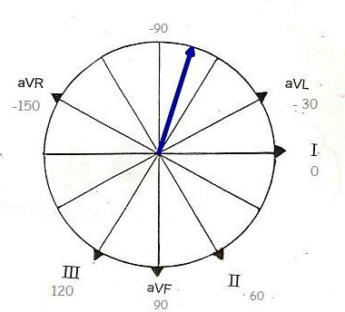
c. If deflection is up, put right thumb up
d. If deflection is down, put right thumb down

Look at your two thumbs…
Left Hand | Right Hand | Conclusion
UP | UP | Normal axis (-30 to 100)
UP | DOWN | Left axis deviation
DOWN | UP | Right axis deviation
DOWN | DOWN | Extreme axis deviation

STEP 4: Intervals
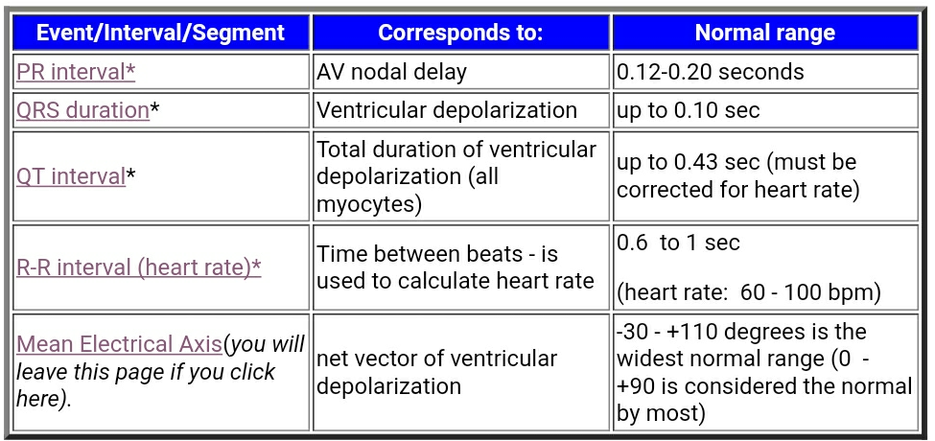

STEP 5: Hypertrophy
Right Atrial Enlargement (P pulmonale) | Left atrial enlargement (P mitrale) | RVH (right ventricular hypertrophy) | LVH (left ventricular hypertrophy) if QRS <0.12 sec
-Tall P >2.5mm in lead II  -Large diphasic P with large initial phase in V1 | -P >0.12 seconds  -Diphasic P with downward terminal phase in V1  -M-shaped P in I, II, or a VL | -RAD >110  -R > S in V1  -R in V1 >7mm  -S in V1 >2mm  -qR pattern in V1  -rSR’ in V1 with R’  >10mm | -R in 1 + S in III >25mm  -R in aVL >11mm  -R in aVF >20mm  -S in aVR >14mm  -R in V5 or V6 26mm  -R in V5 or V6 + S in V1  >35mm  -Largest R + largest S in precordial lead >45mm

STEP 6: Infarction or Ischemia
Progression:
- Hyperacute T waves
- ST segment elevation
- Inverted T waves
- Q wave (0.04 sec and/or >25% height of R wave)

Location | Leads | Vessels
Anterior | V2-V4 | LAD
Anteroseptal | V1-V4 | LAD
Anterolateral | V1-V6, 1, aVL | LAD, diagonal
Inferior | II, III and aVF | RCA, circumflex
Lateral | I, aVL, V5-V6 | Circumflex, diagonal
Posterior | Large R wave in V1-V3 | RCA

STEP 7: Blocks
First degree: PR interval > 0.22 seconds

Second degree:
Mobitz Type I (Wenckebach): PR int increases until a QRS is dropped
Mobitz Type II: PR int constant, QRS randomly drops, more dangerous than type I.
- Pacemaker is recommended
Third degree: P waves at regular intervals, QRS complexes at regular intervals but P waves and QRS waves are independent of each other.

Bundle Branch Blocks:
RBBB: R-S-R’ in V1 or V2 >0.12 seconds
LBBB: R-R’ in I, V5 and V6
QRS >0.12 seconds
Wide S V1-V2
Absence of Q waves in I, V5 and V6

HEMATOLOGY

DVT (deep vein thrombosis): Initial signs of DVT include: erythema, warmth of the affected extremity. Duplex US combines the Doppler and compression methods and offers the quickest, most effective detection method available at the bedside. Upon confirmation of a clot, unfractionated heparin or LMWH therapy should be initiated.

A. UFWH
1. Loading dose = 80 units/kg
2. Initial infusion rate = 18units/kg
3. Draw PTT q6h and follow protocol. Titrate drip to maintain a therapeutic PTT ~60-90 Typical dosing for LMWH:
B. Lovenox: 1mg/kg bid or 1.5mg/kg daily

PE (pulmonary embolism): a clot or portion of a clot from an extremity breaks loose and enters the pulmonary circulation. Symptoms range from asymptomatic to respiratory arrest, depending on size and location of the clot. Manifestations may include dyspnea, tachypnea, hypoxemia. EKG: S1Q3T3 (non-specific)

Diagnosis of PE occurs in stages:
1. Lower extremity duplex scan. If positive, a PE is presumed, and therapy initiated
2. V/Q scan: overall lung parenchyma must be fairly normal otherwise will be difficult to interpret
a. Normal results exclude PE.
b. Low-probability with a negative duplex scan indicated PE is unlikely.
c. Indeterminate results are of no value and indicate further testing is necessary
3. Contrast Enhanced CT scan of chest may allow visualization of a thrombus or suggest alternative diagnosis
4. D-dimer cannot be used as a sole testing method. Negative results may help rule out PE along with other testing methods, but a positive result had no predictive value
5. Pulmonary angiography is the gold standard but caries the greatest risk because of its invasiveness

Treatment options:
**If suspicion is high, start therapy prior to testing - if no contraindication to anticoagulation**
1. Unfractionated heparin (same dose as per DVT)
2. LMWH (same as per DVT)
3. Thrombolytics (9TPA, reteplase, alteplase)
4. IVC Filters
5. Thrombectomy/Transvenous catheter emboli excretion

Secondary prophylaxis involves the administration of anticoagulants to prevent recurrent of thrombotic events. Warfarin is commonly used and must be administered simultaneously with heparin until an INR of 2-3 is achieved. LMWH has also proven successful at secondary prophylaxis but involves greater expense and patient willingness to administer their own subcutaneous injections.

**Duration of therapy is 3 months whether provoked or unprovoked. If unprovoked and bleeding risk is low, then anticoagulation can be continued indefinitely**

Thrombolysis:
-Indication: Persistent hypotension or shock due to acute PE. Need to take the whole clinical picture into consideration.
- in most cases, systemic thrombolytic therapy should be considered only after acute PE has been confirmed because the adverse effects of the therapy can be severe

**If a patient is going to need mechanical thrombolysis the ICU must be made aware

Possible indications | Contraindications | Relative contraindications
--severe or worsening right ventricular dysfunction  --cardiopulmonary arrest due to PE  --extensive clot burden | --high risk of bleeding  --intracranial neoplasms  -- <2 months intracranial or spinal surgery or trauma  -- history of hemorrhagic stroke  --ischemic stroke in <3 months | --severe, uncontrolled BP (SBP  >200 or DBP >110)  --ischemic stroke >3 months  --pregnancy  --recent bleeding 2-4 weeks  --surgery within one month  --current use of anticoagulation  --age >75

Oral Anticoagulants:
Medication | Warfarin/  Coumadin | Dabigatran/  Pradaxa | Rivaroxaban/  Xarelto | Apixaban/  Eliquis | Edoxaban/  Savaysa
Approved Indications | --stroke prevention in afib or prosthetic heart valves  --DVT/PE ppx and tx | --stroke prevention in nonvalvular afib  --VTE ppx in hip/knee replacement  --DVT/PE tx  --DVT/PE ppx of recurrence | --stroke prevention in nonvalvular afib  --VTE ppx in hip/knee replacement  --DVT/PE tx  --DVT/PE ppx of recurrence | --stroke prevention in nonvalvular afib  --VTE ppx in hip/knee replacement  --DVT/PE tx  --DVT/PE ppx of recurrence | --stroke prevention in nonvalvular afib  --DVT/PE tx
Mechanism of Action | Vitamin K antagonist. Inhibits vit K dependent clotting factors (II, VII, IX, X) &  Protein C and S | Direct Thrombin Inhibitor | Factor Xa inhibitor | Factor Xa inhibitor | Factor Xa inhibitor
Onset of Action | Slow onset; 5 to 7 days | Rapid onset; about  2 hours | Rapid onset; above  2.5 to 4 hours | Rapid onset;  about 3 hours | Rapid onset; about  0.5 to 2 hours
Elimination | Hepatic | 80% renal | 33% renal | 25% renal | 50% renal
Renal Adj. | No | Yes | Yes | Yes | Yes
Monitoring | INR | Routine lab monitoring not required: aPTT, ECT (if available), TT (most sensitive) may be used to detect presence of  dabigatran | Routine lab monitoring not required, may use PT to detect presence of rivaroxaban | Routine lab monitoring not required, PT, INR and aPTT may be used to detect presence of apixaban | Routine lab monitoring not required
Reversal agent | Vitamin K  For major bleeding: consider PCC with vitamin K, FFP | Idarucizumab  Dabigatran is 60% dialyzable  Activated charcoal may be used if ingestions occurred in <2 hours prior to  presentation | Andexanet alfa – not usually available; for major bleeding consider PCC or recombinant factor VIIa3  Not dialyzable | Andexanet alfa – not usually available; for major bleeding may consider PCC or recombinant factor VIIa  --Not dialyzable  --Activated charcoal may be used if ingestion occurred within 2- 6 hours of presentation | No specific antidote  Edoxaban is not dialyzable

Disseminated Intravascular Coagulation: DIC
The release of tissue factor from endothelial injury that activates clotting cascade. If systemic = disseminated intravascular coagulation. Results in widespread microvascular thrombosis and can be accompanied by fibrinolysis (simultaneous coagulopathy and bleeding diathesis). Sepsis, particularly with gram negative organisms, is the most common scenario. DIC may manifest as ARDS, kidney or liver dysfunction, or GI bleeding. Diagnosis of DIC: correlation of clinical picture with coagulation studies. Typically, results are as follows:

PT | Increased
PTT | Increased
Platelet count | Decreased
D-Dimer | Positive
Fibrinogen | Decreased
INR | Elevated

Treatment consists of the following measures:
- Treat the underlying disorder
- Administer cryoprecipitate to replace fibrinogen. Monitor for response of INR
- If no correction of INR, administer FFP
- If necessary, transfuse platelets.

Heparin Induced Thrombocytopenia (HIT)
- Occurs when antibodies are formed against the heparin-platelet factor 4 complex.
- Characterized by a 50% fall in platelet count from baseline or to <150,000
- Typically occurs in 4-5 days after onset of heparin therapy
- Can also occur with patients on LMWH (lovenox)
- If evidence of thrombosis – patient should be started on direct thrombin inhibitor
  - Argatroban
  - Bivalirudin – for pts undergoing PCI and have HIT or are at risk of HIT
- Don’t transfuse platelets – because can worsen thrombosis
- Only transfuse if severe thrombocytopenia who are bleeding or undergoing an invasive procedure
- Fondaparinux and NOAC have not been approved for the treatment of HIT
- Duration of treatment:
- If only thrombocytopenia: treat for 4 weeks
- If thrombosis: treat for 3 months with warfarin.
- Warfarin shouldn’t be started until plt > 150K
- Argatroban with warfarin until INR therapeutic x 48 hrs

BLOOD COMPONENT THERAPY
Component | Content | Indications | Results
Packed Red Blood Cells (pRBCs) | ~200 mL red blood cells | Active bleeding Hgb <7 | 1 unit of pRBCs raises  Hgb by ~ 1 mg/dL . Depends on patient size.
Platelets (typically given as “6 pack” which is 1 unit) | 1 unit contains 50-100 billion platelets | <10K  <20K + fever  <50K if bleeding, planned procedure  <100K if intracranial  bleed | Single unit raises platelet count by 5000 – 10000/mm3  **varies**
Fresh Frozen Plasma (FFP) | All coagulation factors | Bleeding due to coagulation factor deficiency if increased  INR (>2) | 3-4 units will typically raise the factor levels by 15%
Cryoprecipitate (cryo) | Factor VIII, vWF, and fibrinogen | Hemophilia, vWD, Fibrinogen <100 | Raises fibrinogen by 25mg/plasma volume of  infusate
Prothrombin complex  concentrate (PCC) | Factor II, VII, IX, X,  protein C and S | Active bleeding on  anticoagulation | **c/i in DIC
Transexamic acid | Antifibrinolytic | Hemophilia, heavy menstrual bleeding, post  op surgical bleeding

Transfusion Reactions
Reaction | Cause | Manifestation | Treatment
Acute hemolytic | Pre-formed antibodies | Quick onset fever, chills, chest pain, low back pain, and possibly hypotension | -STOP transfusion & return remaining blood to lab  - IV fluids for clearing hemolysis products  - maintaining UOP >100mL/hr  -Consider urine alkalinization with sodium bicarbonate
Delayed hemolytic | Formation of new antibodies or amnestic response | Within 3-4 weeks of transfusion, Hct falls and  bilirubin rises
Non-hemolytic, febrile | Reaction to antibodies to done plasma proteins or  WBCs | Fevers, chills, urticarial, pruritus, respiratory distress | Tylenol Benadryl
Volume overload | In patients with CHF, infused volume may cause pleural effusions | Dyspnea | -slow infusion  -Lasix 40mg IV midway through infusion, if patient  can tolerate

Intensive Care Unit

ORGANIZATION OF NOTES

(*) Take pride in your notes. These are important medico-legal documents and reflect your thinking and practice. These are important in resident evaluation as well. Please do not copy and paste forward notes. Edit them to keep them relevant and factual.

ADMISSION NOTE:
Should include all of the following:
HPI – including the traditional elements: in addition to a brief summary of what has been done to the patient since his/her presentation to the hospital, whether she is being transferred from the ED, floor or outside hospital.

**If the patient is admitted from the ED, the history should include time of presentation, medications admitted in the ED, quantity/type of fluid administered, admission labs and reason for transfer to ICU.

**If the patient was admitted from the floor/OSH, include a brief overview of the hospital stay and reason for transfer.

Past Medical History
Past Surgical History
Family History Social History
Home meds/Allergies Focused ROS

All fluids/continuous drips (ex. NS @125cc/hr, Levophed 10mcg/kg/min) Ventilator Settings
Vitals/Physical Exam Labs/Micro/Imaging

A/P - listed by organ system
Neuro: Level of consciousness, RAAS score. (Not Intubated/sedated) EENT:
Pulm:
CV:
Renal:
ID: (include day of Abx, ex: Vancomycin – day 2) GI: (include nutritional information here)
Endo: Heme:

The checklist is a way to tie up important things that tend to be forgotten in the ICU and has been shown to have mortality benefits.

Checklist:
- Medication list reviewed with the Clinical Pharmacist:
- Volume Balance: address goal volume balance for the next 24h
- Lines/Tubes: what kinds of lines they have and where, and date they were placed and whether still required or can be removed. (DC lines as soon as possible)
- Lung protective ventilation: (yes, no or n/a) if no state why
- DVT PPX:
- Pressure PPX: walking, turns q2h, specialty mattress
- GI PPX if indicated: H2B or PPI or n/a
- Sedation:
- Analgesia:
- Antibiotics/Start date:
- FEN: if NPO state why
- Mobility/PT-OT:
- Family updated: This should be done daily

PROGRESS NOTES:
S: Hospital day #, any overnight events as reported by the patient, overnight team or nursing staff
O: Vitals usually in ranges and MAP
Net fluids – I/O (categorize output from any drains) Ventilator settings
Exam
ABGs (pH, pCO2, PO2, FiO2, P:F)
Labs/Micro Imaging Medications
A/P: same as above
Checklist: same as above

PRESENTATIONS:
Hospital Day/MICU day
Overnight events
Vitals
I/O
Ventilator settings
Physical exam
Pertinent labs
Micro/Imaging
A/P by systems
Checklist

Tips:
-Call consults early in day and follow up with their recommendations.
-Each afternoon prior to leaving:
**follow up on any new recommendations from consultants, as well as labs/imaging results (esp new Micro data)
**order appropriate morning labs on all your patients: ABG/VBG, CXR, etc
** talk to your team about procedures, notes, or other needs.

ICU PROPHYLAXIS
GI Prophylaxis
Stress ulcers represent disruptions in the superficial GI mucosa from inadequate blood flow that normally permits regeneration of mucosal tissue. This can cause stress-related mucosal bleeding from the upper GI tract. Therefore, stress ulcer prophylaxis is commonly administered to critically ill patients for the prevention of mucosal bleeding.

Stress ulcer prophylaxis should be limited to high risk patients:
Mechanical ventilation >48 hours
Vasopressors
Coagulopathy (platelet count <50 or INR >1.5)

Methods to prevent the formation of ulcers are:
Enteral feeding
Use of acid-reducing drugs Therapy:
*H2 blocker preferred unless PPI home med or treating GI bleed *
Famotidine 20mg IV BID or daily if renally insufficient
Pantaprazole 40mg IV
*Once extubated and/or off vasopressors, discontinue GI prophylaxis, unless home med or receiving treatment for a GI bleed*

DVT Prophylaxis
All ICU patients have PE/VTE risk because of immobility and critical illness. Every patient should be on chemical prophylaxis, unless contraindicated:
- Active or suspected bleeding
- Thrombocytopenia (relative contraindication)

Chemical prophylaxis:
Heparin 5000 units SQ TID or Lovenox 40mg SQ daily if GFR>30.

Sequential Compression Devices (SCDs): provide repetitive external compression to the lower legs to facilitate venous return.
- SCDs unless on chemical prophylaxis or contraindicated:
o Severe swelling
o Lower extremity ulcers/burns (Consider upper limb SCDs)

ICU Psychosis/Delirium
Experienced in ICU or critically ill patients resulting in cluster of serious psychiatric symptoms. Worsened short and long-term outcomes and increased mortality.

Risk Factors and Causes:
- Medical Illness, advanced age, known neuro or psych disorder.
-Environmental: Unfamiliar environment, day/night cycle disruption, sunlight exposure, isolation, away from family and friends.
-Sleep deprivation: disturbance of hospital staff checking vitals, giving medications, baths etc. Alarms, light, and noise.
-Medications: BZD, other sedatives, analgesics, antibiotics, continuous medical monitoring with alarms.

Prevention/Treatment:
- Frequent reorientation (even if sedated)
- Keep lights on during the day, window blinds open, TV on
- Keep light off at night, TV off, minimize night disturbances
- Encourage family visits
Data limited about pharmacologic treatments: typical and atypical sedatives are commonly used in agitated patients.

(*) Hypoactive delirium is much more common than hyperactive delirium

ICU PULMONARY

Supplemental Oxygen
1. Low flow oxygen devices: usually < 6L/min. These devices provide pure oxygen as a fraction of the minute ventilation. The remainder is filled by room air. Oxygen delivery is dependent on respiratory effort and minute ventilation. These devices are:
Device | Flow Rate | FiO2 | Comments
Nasal Cannula | 1-6 L/min | 24 – 44% | Flows above 6L/min don’t  increase FiO2 >.44
Oxygen Mask | 6-10 L/min | 35 - 60% | Ex. Misty ox, simple face mask
Reservoir Cannula | 1-6 L/min | 24 – 50% | Ex: Oxymizer (mustache) or  oxymizer pendant form;  designed to conserve O2

2. High flow oxygen devices: Meet or exceed inspiratory demands.
Device | Flow Rate | FiO2 | Comments
Venturi Mask | 4-12L/min | 24-50% | Delivers a precise O2 concentration, therefore CO2 retention is minimal
High flow NC | 5-60 L/min | Up to 60%
Non Rebreather | 10-15L/min | 60%
Opti-flow | 60L/min | Up to 100% | Good for use in pts with contraindications to NIV therapy and also provides some ventilatory support. (some positive pressure which cannot be quantified)
Vapotherm | 40L/min | Up to 100% | Same as above

Respiratory Failure
Inadequate gas exchange due to dysfunction of one or more essential components of the respiratory system.

4 Types of Respiratory Failure

Type 1: hypoxemic (PaO2 <60) – Failure of oxygen exchange
Hypoventilation: drug overdose, chest wall trauma, muscle weakness, stroke or brain tumor involving the respiratory center, OHS
  - Frequently associated with hypercapnia
Diffusion Limitation: scarring or abnormally thickened blood/gas barrier such as pulmonary fibrosis or other forms of interstitial lung disease
Shunt: respond poorly to increased FiO2
  - Anatomic shunt: pulmonary AVMs or intra-cardiac shunt
  - Physiologic shunt: severe PNA with ARDS
V/Q mismatch: most common. Mismatch ventilation and blood flow impairs the uptake or elimination of gases by the lung
  - Ventilation also affected – may have component of type 2
High altitude: Low partial pressure of oxygen. Normal A-a gradient

Type 2: Hypercapnic / Ventilatory (PaCO2 >45 or more than expected) – Failure to exchange or remove carbon dioxide
- Due to a decreased minute ventilation relative to demand
- Increased dead space ventilation
- Central hypoventilation
- Neuromuscular diseases
- Obstruction (COPD/Asthma/OHS)

Type 3: Peri-operative – increased atelectasis due to low functional residual capacity.
- Post-operative analgesia / Splinting (especially with upper abdominal wall incision)
- Obesity, ascites
- Pre-operative tobacco smoking
- Excessive airway secretions
- Undiagnosed OSA
- Anesthetic and analgesic medication effect

Type 4: Shock
        - The goal of ventilation in this setting is to stabilize gas exchange, unload the respiratory muscles, lowering their oxygen consumption and for severe acidosis

Non-invasive positive pressure ventilation
1.CPAP (continuous positive airway pressure)
- delivery of a continuous level of positive airway pressure. Functions similar to PEEP.
- patients must initiate all breaths
- no additional pressure above the level of CPAP is provided
- commonly used for OSA

2.BIPAP (bi-level positive airway pressure)
-Unlike CPAP, respiratory pressures are augmented.
-Inhalation positive airway pressure (IPAP) and the exhalation positive airway pressure (EPAP) are adjusted for optimization of ventilation.
-the tidal volume usually correlates with IPAP and EPE difference.
Ex. IPAP 15 & EPAP 5; tidal volume generated based on pressure of 10
Ex. IPAP 10 & EPAP 5, tidal volume generated based on the pressure of 5

Indications:
- Congestive heart failure
- COPD exacerbations (esp hypercapnea)
- Asthma exacerbation (use with caution, very limited data)
- OHS/OSA
- Neuromuscular weakness
- pre-oxygenation prior to intubation
- Intubation refusal
- Post Extubation in select patients

Contraindications:
- Need for emergent intubation
- Altered mental status, inability to protect airway (high aspiration risk)
- Inability to tolerate mask, cooperate
- Active vomiting
- Cardiac or respiratory arrest
- Hypoxemic respiratory failure due to pneumonia (relative contraindication)

**if AMS thought from hypercapnic encephalopathy, consider trial of NPPV. Monitor patient closely. If no improvement w/in ~1-2 hrs, patients should be promptly intubated.**

Invasive Mechanical Ventilation
Indications:
- Apnea
- Respiratory failure
- Impending respiratory failure
- Inadequate oxygenation
- Inability to protect airway

Modes:
1.AC/VC – assist control/volume control
Variables:
- TV (tidal volume) – usually set at 6-8cc/kg of ideal body weight
- RR – respiratory rate
- PEEP – positive end-expiratory pressure: the pressure at end-expiration required to keep the alveoli patent / augment FRC
- FiO2 – amount of inspired oxygen
In this mode, ventilator delivers min. number of breaths (set rate) with set tidal volume. Breath at set tidal volume can be patient triggered or machine delivered. Look for ventilator synchrony. Keep a close eye out for the ventilator pressures.

2.AC/PC – assist control/pressure control
Variables:
- Inspiratory Pressure (Pi): pressure delivered during inspiration
- RR – respiratory rate
- PEEP – positive end-expiratory pressure: pressure at end-expiration required to keep the alveoli open
- FiO2 – amount of inspired oxygen
In this mode, tidal volume varies. Based on compliance of the lungs. Tidal volume delivered (mandatory or patient triggered) is based on driving pressure OR Pi – PEEP.

Compliance is lungs ability to stretch and expand. Poor compliance (stiff lungs) requires higher Pi to deliver an adequate tidal volume. As the patient improves (lungs are more compliant) and lower Pi is used to deliver the same tidal volume. Compliance changes over minutes to hours to days thus close monitoring of tidal volume is essential.

3. PS - Pressure Support
Variables:
- PEEP
- Pressure support – similar to Pi: pressure delivered in inspiration
- FiO2
Patient initiates every breath. No mandatory breaths by ventilator. Tidal volume determined by set pressure support and PEEP. If apneic, ventilator has back-up mode and will return to previous mode settings.

4.SBT – spontaneous breathing trial
- essentially pressure support mode with pressure set at 5.
- SBT done for at least 30 minutes prior to extubation (see below for more details)

5.T piece trial
- a form of SBT when patient is disconnected from ventilator and placed on blow-by supplemental oxygen.
- Done in high risk patients prior to extubation (low EF, neuromuscular weakness, etc)

Less commonly used modes of ventilation in the MICU:
6.SIMV – synchronized intermittent mandatory ventilation
Variables:
- TV (tidal volume) – usually set at 6-8cc/kg of ideal body weight
- RR – respiratory rate
- PEEP – positive end-expiratory pressure
- FiO2 – amount of inspired oxygen
- Support – either pressure or volume
Similar to AC/VC. But patient initiated breath is unassisted. Tidal volume delivered varies based on pressure support set.

7.APRV – airway pressure release ventilation
Salvage mode used in certain circumstances: i.e. difficult to oxygenate. Effectively inverse ratio pressure control.
Variables:
- P-high and P-low to determine driving pressure (VT will depend on pulmonary compliance)
- T-high and T-low to determine time at each pressure
- RR – respiratory rate
- FiO2 – amount of inspired oxygen
- Wean by “drop and stretch” – slowly lowering P-high pressure and/or time on P-high
In modes based on pressure control (AC/PC and APRV), keep an eye on MVe (minute ventilation) and tidal volumes as these modes do not guarantee a tidal volume delivery and you risk under-ventilation.

Criteria for Extubation:
1. Reason for mechanical ventilation has resolved
2. Awake, able to follow commands (adequate mental status)
3. Minimal secretions
4. Acceptable hemodynamics (ideally off vasopressors)
5. PEEP is set at 5 and FiO2 is <50% with adequate oxygenation
6. Pass SBT: must be on this mode for 30 minutes
a. RSBI (rapid shallow breathing index) = RR/TV (in L).
< 105 à Unlikely to need re-intubation
Ex. On SBT: RR 34 BPM & average tidal volume of 300cc.
RSBI = 34/0.3 = 113 à high chance of failing extubation

Ex. Following day, during SBT, RR 22 bmp & TV450cc.
RSBI = 22/0.45 = 49 àExtubate!!

**During an SBT, pay attention to hemodynamics (blood pressure, heart rate). If a patient becomes extremely tachycardic and/or hypotensive caution should be taken with extubation. **

Acute Respiratory Distress Syndrome (ARDS)
ARDS is characterized by widespread lung inflammation from activation of inflammatory cascade resulting in diffuse alveolar injury and surfactant dysfunction. Impairs gas exchange and has high mortality.

Many causes, with examples:
-pneumonia/aspiration -pancreatitis
-sepsis -inhalation injury/drowning
-trauma/pulmonary contusion -severe burns
-sepsis/septic shock -TRALI
-drug overdose

Berlin Criteria for diagnosis of ARDS
- Timing: <1 week onset
- Imaging: bilateral lung opacities
- Origin of edema: respiratory failure is not fully explained by cardiac failure or fluid overload
- Oxygenation: based on PaO2/FiO2
- Mild: P/F <300
- Moderate: P/F <200
- Severe: P/F <100
Treatment: Treat the underlying cause. Lung Protective Ventilation.
ARDS are particularly susceptible to lung injury from mechanical ventilation: volutrauma, barotrauma and atelectrauma.
Lung Protective Ventilation includes:
1. Tidal Volume: 6-8cc/kg Ideal body weight (min 4 cc/IBW)
2. Plateau pressures must be <30cmH2O
a. Plateau pressure = pressure applied to small airways and alveoli. Measured from inspiratory hold.
3. Wean FiO2 <60% in first few hours by increasing PEEP.
FiO2 >60% for > 24hrs may cause lung injury.
Follow ARDSnet protocol for High PEEP; low FiO2 (see chart below)

Other Therapies: If high PEEP and FiO2 and unable to oxygenate,
1. Proning (improves mortality if done early; 16 hours a day)
2. Paralytics (mortality benefit in early ARDS)
3. APRV
4. iNO/Flolan (limited data)
5. ECMO
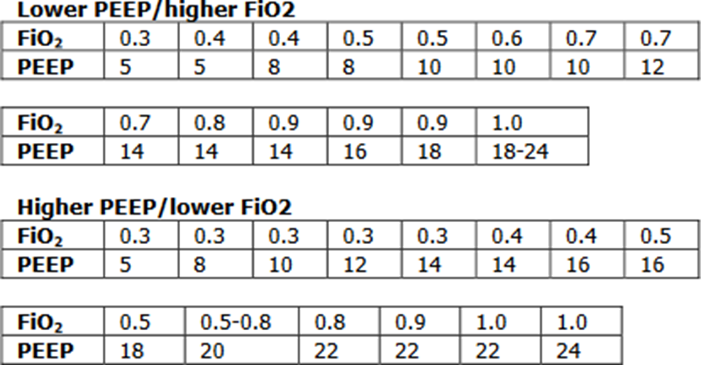
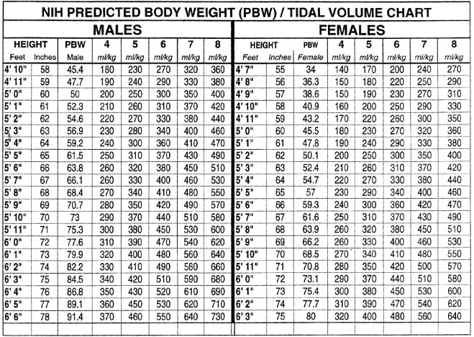

Trouble shooting high peak pressures:
PIP: peak inspiratory pressures – Max pressure during inspiration measuring airway resistance and lung compliance.

Plateau pressure: pressure applied to small airways and alveoli. Applying an inspiratory hold measuring lung compliance.

If high peak pressures but plateau <30 =Increased airway resistance
1. Kinked ET tube, or pt is biting down on ET tube
2. Mucous plug/excessive secretions
3. Bronchospasm
4. Water in the tubing system

Both peak & plateau pressure elevated = Decreased Pulm Compliance:
1. Pulmonary edema
2. Hemothorax/worsening pleural effusion
3. Ascites/abdominal compartment syndrome
4. Tension pneumothorax
5. Worsening consolidation/ARDS

Acid/Base
General Rules:
1.Always consider the clinical scenario.
2.You need both an ABG and a renal panel to fully evaluate.
3.Normal values
pH: 7.35 - 7.45 --> normal 7.40
pCO2: 35 - 45 --> normal 40
pO2: 80 - 100
bicarb: 24 - 28
Anion gap: 8 - 12 (must correct for albumin; every 1g albumin below normal (normal = 4), expected AG drops by 2.5)
5.The body can never over compensate for primary acid-base disorder.
6.Respiratory compensation is fast (minutes to hours)
7.Metabolic compensation is slow (days)

STEP 1: Identify primary process – Is pH up or down?
Elevated (>7.40): Alkalosis
Decreased (<7.40): Acidosis

STEP 2: What is the primary process?
Is pH and pCO2 abnormality in the same direction (i.e. both elevated or both decreased)?
Yes – primary metabolic disorder
Metabolic acidosis: HCO3 <24 or alkalosis: HCO3 >24
No – primary respiratory disorder
Respiratory acidosis: paCO2 >45 or alkalosis: paCO2 <35

STEP 3: If primary metabolic disorder, calculate Anion Gap

STEP 4: If anion gap, calculate delta gap for other metabolic processes
**many people do this differently, this is one method**

[calculated AG – 12] + measured HCO3 = corrected bicarb
--if corrected bicarb is >24 then metabolic alkalosis co-exist
--if corrected bicarb is <24 then NAGMA co-exist
--if corrected bicarb = 24 no other metabolic process exist

STEP 5 If main disorder is respiratory, is it acute or chronic?
Acute (<8hrs) expected ∆pH = 0.008 x (40 -pCO2)
Chronic (>24hrs) expected ∆pH = 0.003 x (40 - pCO2)

STEP 6 If metabolic acidosis present, is respiratory compensated? Winter’s Formula =(1.5 x serum HCO3) + 8 = expected pCO2 +/- 2
--If pCO2 is < expected = resp alkalosis
--if pCO2 is > expected = resp acidosis

STEP 7 If isolated metabolic alkalosis, is compensated?
--if pCO2 <40, also resp alkalosis
--if pCO2 >50, also resp acidosis
--if pCO2 = 40 - 50, normal resp response

Metabolic
Increased AG acidosis | Normal AG acidosis | Alkalosis
-Methanol  -Uremia  -DKA  -Paraldehyde  -INH  -Lactic acidosis  -EtOH  -Ethylene glycol  -Salicylates  -Rhabdo | -RTA  -NS induced- hyperchloremia | -Diuretics  -Licorice  -Vomiting  -Diarrhea  -NG suction  -Refeeding syndrome  -Conn’s/Cushing’s  -Barter’s

Respiratory
Acute Acidosis | Chronic Acidosis | Alkalosis
Anything Causing Hypoventilation  -CNS depression (opoid overdose)  -Airway obstruction  -pneumonia  -pneumothorax/hemothorax  -pulm edema  -mechanical hypoventilation | -COPD  -restrictive lung disease  -neuromuscular disorders | -CNS disease (trauma, CVA, ICH)  -encephalopathy  -anoxic brain injury  -anxiety  -sepsis  -hypoxia  -salicylates  -mechanical hyperventilation

Procedures

Central Lines
- Important way to get access if unable to obtain peripheral access
- Important for pressors to reduce risk of peripheral vasospasm and necrosis
- 100% sterile procedure
- IJ safest in a patient on positive pressure ventilation and in very thin patients. Large neck may be technically challenging
- Femoral may be a good consideration in a patient with very high risk of bleeding as it is a compressible location
*Prior to starting the procedure ensure informed consent is obtained
*Locate the U/S and identify target vessel
*Obtain sterile equipment
*Video demonstrating technique:
https://www.youtube.com/watch?v=HE5QhsPRaPU

Paracentesis
Indications: diagnose cause of ascites, evaluate for infectious process, symptomatic relief
Complications: pain, bleeding, infection, bowel perforation, liver/spleen laceration, persistent leakage of fluid
*Prior to starting the procedure ensure informed consent is obtained
*Locate site for puncture with U/S. Perform Doppler prior to needle insertion
*Obtain sterile equipment
*If you are doing a diagnostic paracentesis only you do not need the paracentesis kit. Can use 50 cc syringe and needle.
Labs: Serum Albumin, Fluid Albumin, fluid total protein, culture (in aerobic and anaerobic blood culture bottles), glucose, LDH, gram stain, amylase, AFB, cytology, +/- triglyceride, bilirubin, serum BNP
*Video demonstrating technique
https://www.nejm.org/doi/full/10.1056/NEJMvcm062234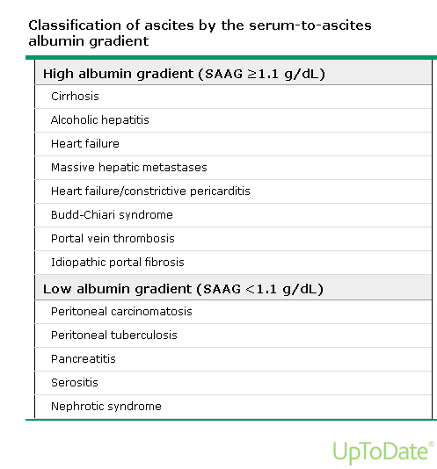

Lumbar Puncture
Indications: infectious process, subarachnoid hemorrhage evaluation with negative CT, assessing the etiology of a headache or fever of unclear origin
Complications: pain, bleeding, infection, post-procedure headache, brain herniation, persistent leakage of fluid
Contraindications: Alteration in mental status or focal neuro deficits should get a non-con CT of the head first to assure no elevated intracranial pressure; if this is the case, start the antibiotics before the CT and do the procedure immediately afterward – never wait to start antibiotics if you suspect bacterial meningitis for any reason!!
*Prior to starting the procedure ensure informed consent is obtained
*Obtain sterile equipment
*Video demonstrating technique
https://www.nejm.org/doi/full/10.1056/NEJMvcm054952
Studies to be sent:
Tube #1: cell count and diff; Tube #2: glucose, protein, VDRL; Tube #3: culture and gram stain (any special studies should be added to this one including cytology, TB, viral panels, crypto latex agglutinin); Tube #4: cell count and diff (again)

Thoracentesis
Indications: therapeutic relief of dyspnea, diagnosis of unknown effusion, removal of parapneumonic effusion, concern for infected or malignant fluid
Possible Complications: pain, bleeding, infection, hemothorax, pneumothorax, costal nerve damage, damage to liver or spleen
*Prior to starting the procedure ensure informed consent is obtained
*Locate site for puncture
*Recall VAN complex on the lower aspect of each rib
*Don’t insert needle below the 9th rib
*We usually avoid removing more than 1.5L at a time to try and avoid reexpansion pulmonary edema
*Obtain sterile equipment
*Video demonstrating technique
https://www.youtube.com/watch?v=ivTyH09BcHg

Pleural Effusions:
Common Causes:
Exudate
- Infection
- Malignancy
- PE
- Hemothorax
- Chylothorax
Transudate
- CHF
- Cirrhosis
- Nephrotic syndrome
- Hypoproteinemia

Light’s Criteria: (One or more true, fluid is exudative)
- Pleural protein/serum protein >0.5
- Pleural LDH/serum LDH >0.6
- Pleural LDH > 2/3 upper limit of normal for serum LDH
Empyema: pH <7.20; gram stain +, culture + or frank pus
**Indication for chest tube placement

Complicated parapneumonic effusion:
Exudative, predominantly neutrophilic. Low glucose (<60). Elevated LDH. Fluid is cloudy. Typically requires a chest tube for drainage.

Uncomplicated parapneumonic effusion:
Exudative, predominantly neutrophilic. Fluid maybe clear or slightly cloudy but gram stain and culture are negative. They normally resolve with antibiotics alone

Other causes of decreased pH (<7.20): rheumatoid arthritis, esophageal rupture

Chest Tube Indications:
1. pneumothorax
2. empyema, complicated pleural effusion

Definitions for chest tube management:
Atrium: See picture below. What is connected to the chest tube & where the fluid is collected.

Suction: suction tubing connects to the atrium and then to wall suction. To know the chest tube is actually to suction, the orange accordion will show through window in the upper left corner. Suction is usually set at -20. When a chest tube is first placed, it is usually connected to suction, especially if it was placed for management of a pneumothorax.

Water seal: when no suction is connected. The orange accordion will not be visible. Usually the tube should be on water seal prior to removal.

Clamped: the tubing is clamped. This is not always done, but in high risk patients the tube will be clamped to ensure fluid (effusion) or air (pneumothorax) does not re-accumulate. This is a representation of not having the tube in place.

Air leak: if an air leak is present, bubbles will be seen in the bottom left corner every time the patient take a breath. This indicates the presence of a pneumothorax or bronchopleural fistula.

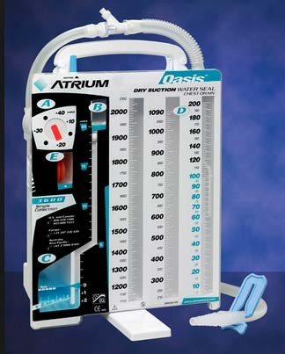

Video: https://www.youtube.com/watch?v=MAeum5dlZFo

SEDATION

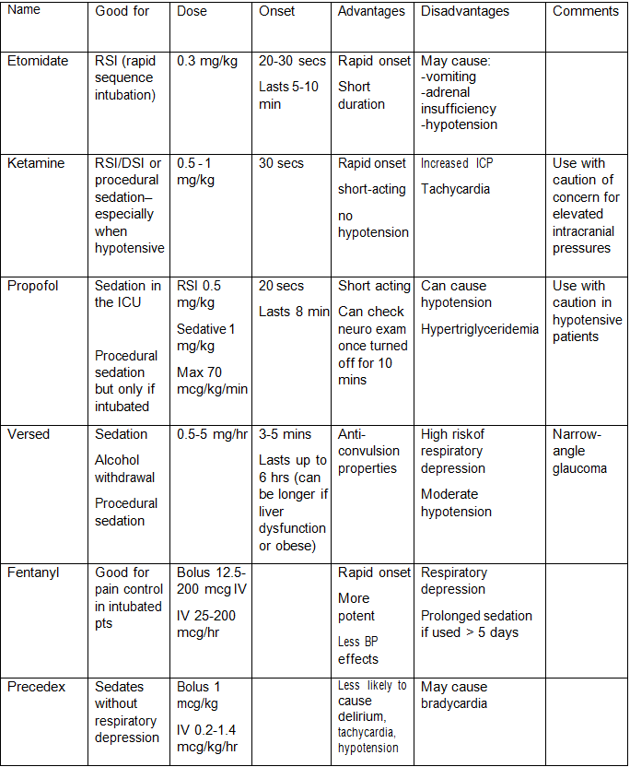

Paralytics
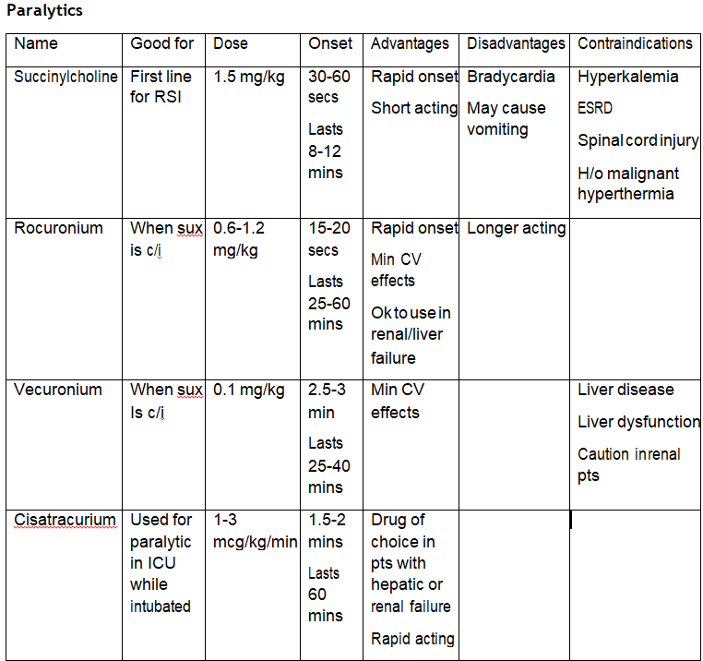

ABCDE Bundle
Group of evidence-based interventions divided into 3 components to prevent complications of critical illness.

ABC – Awakening and Breathing Trial Coordination
Daily sedation vacations decrease overall ICU length of stay by decreasing ventilator days and hospital acquired complications. Over-sedation and under-sedation can lead to prolonged ventilator times. The Bundle addresses sedation vacation and Spontaneous Breathing Trials to promote earlier extubation.

D- Delirium Assessment and Management
All patients are susceptible to delirium. Unfortunately, often goes undetected and untreated leading to long-term consequences. Early identification and management of delirium

E – Early Exercise and Progressive Mobility
Prolonged bedrest or immobility are prone to developing muscle weakness and atrophy and can increase hospital stay and long-term muscle dysfunction. The “E” bundle encourages progressively more activity and possibly walking while intubated.

As a team, focus on the “ABC” portion of the bundle in order for “D” and “E” to fall in place. Every morning a sedation vacation should be attempted unless:

Contraindications:
Active seizures
Active alcohol withdrawal
Paralyzed patients

Relative contraindications:
high amounts of pressures/FiO2

If no contraindication, sedation should be stopped, and patient monitored closely. During this time neurologic status should be evaluated. If following commands, SBT should be performed. Never stop sedation on a paralyzed patient!

Examples of Sedation Vacation Failures
Anxiety/agitation: try fentanyl bolus
RR >35
O2 sat <88%
Respiratory distress
Hemodynamic instability/arrhythmia

ICU References

Doherty DE, Petty TL, Bailey W, et al. Recommendations of the 6th long-term oxygen therapy consensus conference. Respir Care. 2006; 51(5):519-525.

Kory RC, Bergmann JC, Sweet RD, et al. Comparative evaluation of oxygen therapy techniques. JAMA 1962; 179: 123-128.

McCoy, R. Oxygen conserving devices and techniques, Respir Care 2000; 45:95-103

Ferguson ND, Fan E, Camporota L, et al. Erratum to: The Berlin definition of ARDS: an expanded rationale, justification, and supplementary material. Intensive Care Med 2012; 38: 1573-1582

Morgan, Edward G., Maged Mikhail and Michael Murry. Clinical Anesthesiology, Fourth edition, 2006. McGraw Hill, Philadelphia. Pg. 82

Bauman, KA., Hyzy, RC. Noninvasive positive pressure ventilation in acute respiratory failure in adults. In UpToDate, Waltham, MA. Updated Jun 2016.

Uptodate.com

AHA. Advanced Cardiovascular Life Support Provider Manual 2015

Sharma S. emedicine- Respiratory Failure. Retrieved July 7, 2016 from http://www.emedicine.com/med/topic2011.htm

The Acute Respiratory Distress Syndrome Network (2000). Ventilation with lower tidal volumes as compared with traditional tidal volumes for acute lung injury and the acute respiratory distress syndrome. New England Journal of Medicine, Volume 342, Number 18, p 1301-1308.

Moe, S.M. Disorders Involving Calcium, Phosphorous and Magnesium. Prim Care. 2008 Jun; 35 (2): 215-vi
Rivers E, Nguyen B, Havstad S, et al. Early goal-directed therapy in the treatment of severe sepsis and septic shock. New England Journal of Medicine. 2001;345:1368-1377

How to call a consult
C | Contact the Consultant Courteously: Your Name, training level, “I am requesting a Consult, please”
O | Orient: Patient name, MRN, Floor, Bed
N | Narrow Question: Ask a focused question(s) regarding diagnosis (workup, procedure) and/or management (treatment, pre-op)
S | Story: Patient age, sex, pertinent history, hospital course, relevant labs, radiology, anticipated plan
U | Urgency: When to evaluate patient? 30 – 60 mins (emergent), 2-3 hrs (very urgent), 8 hrs (urgent), 24 hrs (routine)
L | Later: Make a follow up plan with the consult (how and by when) and give your pager/cell number
T | Thank you!

Cardiology
- Cardiologist
- Cardiac History and Etiology (Heart Failure, Arrythmia, CAD (stents and where))
- Risk Factors (Tobacco, HLD, HTN, DM)
- Last Stress Test, Cardiac Catheterization
- Troponin, BNP
- EKG: Including your interpretation
- CXR: if relevant
- Echo, Stress Test
Pulmonary
- Pulmonologist
- Pulmonary History and Etiology (COPD, Asthma, ILD, Pulm HTN)
- Last PFT, CT, Right Heart Cath, RVSP
- Blood Gas (VBG or ABG)
- Imaging: CXR, CT
- BAL, biopsy, Pleural Fluid Labs, if indicated
Nephrology
- Nephrologist: AKDHC, SW Kidney, UMC
- Baseline Creatinine
- DM, medications, hypotension, hypertension, contrast, retention
- Urine output, Volume Status
- Creatinine, Potassium, Bicarbonate
- UA (protein, blood, WBC), PCR, ACR
- Urine Lytes (FeNa, FeUrea)
- GN labs if indicated
- Renal Ultrasound, Bladder Scan, +/-Cross Sectional Imaging
Gastroenterology
- Gastroenterologist, Hepatologist
- Melena vs Hematochezia
- Cirrhosis (etiology, varices, ascites, encephalopathy)
- EtOH (last drink), Med (NSAIDs, PPI), Viral Hepatitis
- Last Colonoscopy, Endoscopy
- Rectal Exam, (i.e. all suspected GI bleeds)
- Platelets, hemoglobin (from baseline), INR, Sodium, BUN, Cr, LFT’s, Bili (fractionated), Ascitic Fluid Labs
- US, Cross Sectional Imagine (CT, MRI, MRCP)
Infectious Disease
- Travel history, sick contact, pets, insects exposure, rashes, Sexual history, IV Drug
- Cultures and sensitivities
Heme/Onc
- Cancer Screening
- Oncologist
- Staging, location of metastases
- Biopsy, peripheral smear, LDH, CBC w/ diff

Antibiotic Coverage

ACLS Algorithms
