Nephrology Kudos 2018
Multidisciplinary Stone Clinic
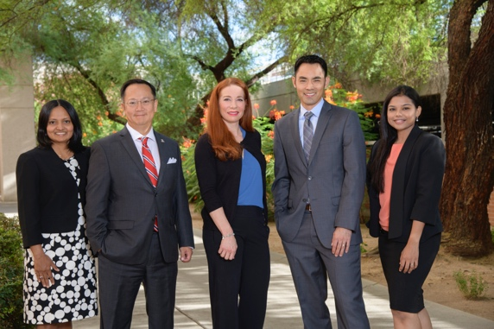
The Divisions of Nephrology and Urology have just started a Multi-disciplinary Stone Clinic that involves specialists from nephrology, urology and nutrition working together to provide the best possible care for patients in Southern Arizona with kidney stones. Initial funding for the clinic comes from a Banner Best Use grant that was submitted by Drs. Koppula and Lee. The clinic will be led by Drs. Sangeetha Murugupandian and Bijin Thajudeen from Nephrology and Drs. Ben Lee and David Tzou from Urology. The goal of the clinic will be to provide a comprehensive one stop service for the prevention and treatment of kidney stones. A special emphasis will be placed on teaching, training, clinical research and the use of the latest most effective technologies.
Patient Panel
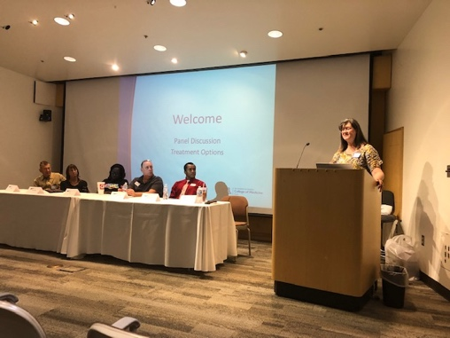
Jackie May, a nurse practitioner in the Division of Nephrology hosted a chronic kidney disease (CKD) and end stage renal disease (ESRD) patient panel. The goal of the panel was a focus on patients learning from other patients. The panel comprised a variety of people living with kidney disease, or who had been touched by kidney disease, and included kidney donors, transplant recipients and dialysis patients. The panel was attended by about 40 people, including patients, care givers, nurses, dieticians and coordinators. We hope that this panel will be the first of many in Southern Arizona and we hope to extend this model to other parts of the state and region.
Plenary Session Lecture at the Southwest Nephrology Conference
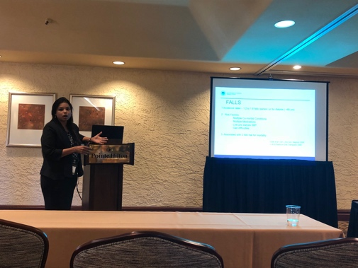
Dr. Sangeetha Murugapandian delivered an outstanding plenary session lecture at the annual Southwest Nephrology Conference in Phoenix on October 6, 2018. Sangeetha spoke on the topic of “Modality Choice for Older Patients with ESRD”. Both Drs. Murugapandian and Thajudeen were also on the planning committee of the Southwest Nephrology Conference. Dr. Murugapandian, who is dually trained in both Nephrology and Geriatrics will also be setting up a dedicated Geriatric Nephrology clinic. She has also been appointed as the Associate Program Director for the Nephrology fellowship.

Invited Presentation by Dr. Chong at the Transplant and Access Symposium at Louisiana State University, Shreveport
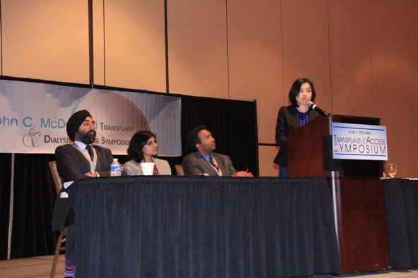
Dr. Chyi Chyi Chong was invited to be a faculty member and speaker at the Transplant and Access Symposium that was hosted by Louisiana State University, Shreveport.

Fellow Survival App
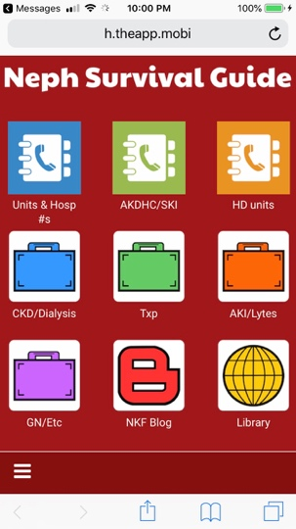
Dr. Hannah Tiu created a Nephrology Fellow Survival App with detailed information available at the tips of your fingers! Specific modules include administrative (hemodialysis units/community groups/hospital wards), therapeutic (CKD/Dialysis/Transplant/Glomerulonephritis/AKI) and informational (NKF Blog/Library) information.

Invited Chapters
Drs. Thajudeen and Murugapandian have been invited to write a chapter for the second edition of Chronic Kidney Disease edited by Kimmel and Rosenberg. The chapter focuses on “Novel Therapies for Chronic Kidney Disease”. Dr. Frank Brosius will be writing a chapter on “Diabetic Kidney Disease” in the same book.
American Society of Nephrology Annual Meeting, San Diego 2018
Members of the Division of Nephrology were extremely active during the recent American Society of Nephrology meeting in San Diego. This is the largest nephrology gathering in the world with almost 13,000 nephrologists registering for this meeting.
Dr. Erica Bracamonte: 6 Pathology pre-course lectures
Dr. Akinlolu Ojo: 4 posters
Dr. Titi Ilori: 1 poster
Dr. Amy Sussman: 1 poster
Dr. Lance Bechtold: 1 poster
Dr. Frank Brosius: Symposium Moderator and poster
Dr. Diego Celdran-Bonafonte and team: 2 posters
Dr. Prabir Roy-Chaudhury: 2 symposium presentations/ASN TV Interview/Moderator/5 posters/1 oral communication
Poster at ADVICE Conference
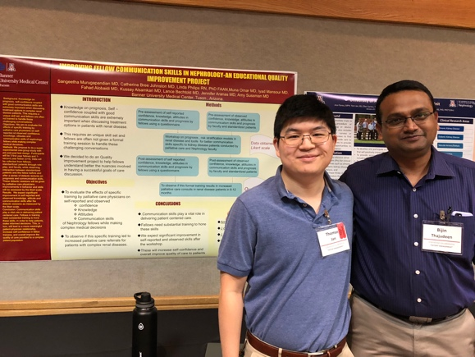
Tom Jan, Clinical Research Coordinator in the Division of Nephrology had a poster and also manned a booth at the Annual Advice Conference organized by the Arizona Department of Health.

Fellow Poster Presentation
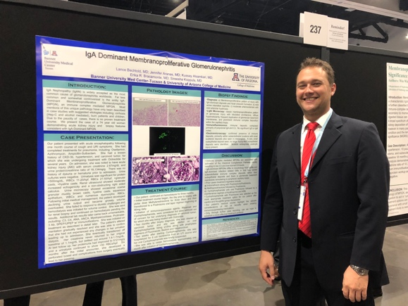
Dr. Lance Bechtold was the lead presenter on a poster on IgA Nephropathy at the American Society of Nephrology, annual meeting in San Diego.

Arizona Kidney and Vascular Center Poster
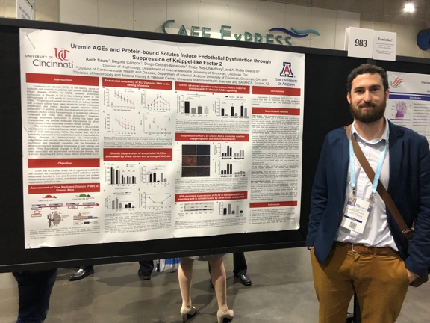
Dr. Diego Celdran-Bonafonte, Assistant Professor in the Division of Nephrology presenting a poster at Kidney Week 2018. Diego was also appointed as the Chair of the VA IACUC (institutional animal care and use committee) and is a member of the University of Arizona IACUC.

Interim Director of Kidney and Pancreas Transplant
Thanks to Dr. Lavanya Kodali for performing an outstanding job as the interim director of kidney and pancreas transplant from October 2017 to September 2018. Lavanya shouldered this additional responsibility with confidence and style and strengthened the 100+ kidney program at the University of Arizona.
Welcome to our New Transplant Nephrologists
An enthusiastic welcome to our new medical director of kidney and pancreas transplantation, Dr. Angelo DeMattos and to Dr. Pablo Loarte Campos who is joining as an Assistant Professor of Medicine/Nephrology.
Nephrology Teaching and Training
Dr. Amy Sussman continues to lead educational activities within the College of Medicine at a divisional (Fellowship Training Program Director), departmental (Vice Chair for Education) and institutional (Director of the 3rd year medical student elective) level.
ASN Councilor and KHI Recognition
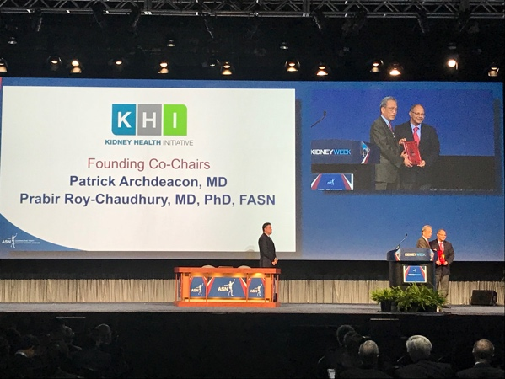
Dr. Prabir Roy-Chaudhury was elected as a Councilor at Large of the American Society of Nephrology starting January 2019. The 8 member council serves as the apex leadership group of the 20,000 member strong American Society of Nephrology (ASN) which is the largest professional nephrology organization in the world. Dr. Roy-Chaudhury was also recognized at an ASN plenary session for his leadership of the Kidney Health Initiative, a public-private partnership between ASN and FDA, over the last 6 years.

Academic Productivity
Since January 2018, faculty in the Division of Nephrology have published over 20 manuscripts and have delivered over 30 invited presentations all over the world.

